CSS ISLAMIC STUDIES · T1QA
بِسْمِ ٱللَّهِ ٱلرَّحْمَٰنِ ٱلرَّحِيمِ
Topic I — Introduction to Islam and the Islamic Beliefs
The Question Answers · Every past-paper question of Topic 1, 2015–2026, answered as a model
Ten questions answered in nine model answers (2022 Q5 and 2024 Q4 are the same question). Each begins with an answer map, decodes the question, builds its headings from the question's own words, and proves every heading from the Quran, the Sunnah and the scholars.
Edition of September 2026 · covers the papers of 2015–2026 · written for CSS 2027 and after
Contents
HOW TO BUILD THE CONTENTS
The Contents below is left empty on purpose. In Microsoft Word, right-click anywhere on the grey line below and choose Update Field → Update entire table → OK. The full table of contents with page numbers will appear.
On a Mac: right-click (or Control-click) the line → Update Field. If you edit the notes later, repeat this step to refresh the page numbers. You can also press Ctrl + A then F9 (Windows) to update every field in the document at once.

How to Use These Answers 6
What is in this document 6
How every answer is built 6
Answer 1 · Din and Religion; the Importance of Din (CSS 2016) 7
Decoding the question 7
The model answer 8
(1) Introduction 8
(2) The meaning of Deen 8
(3) The meaning of religion 9
(4) The difference between Deen and religion 10
(5) The importance of Deen for the individual 12
(6) The importance of Deen for society 13
(7) The importance of Deen for humanity today 14
(8) Conclusion 15
Why this answer scores 15
Answer 2 · The Importance of Deen as the Doctrine of Life (CSS 2022) 16
Decoding the question 16
The model answer 17
(1) Introduction 17
(2) Deen as a doctrine of life 17
(3) Importance in the spiritual life 17
(4) Importance in the moral life 18
(5) Importance in family and social life 19
(6) Importance in economic and political life 20
(7) The difference between Deen and religions 21
(8) Conclusion 22
Why this answer scores 22
Answer 3 · The Supremacy of Wahi (CSS 2015) 23
Decoding the question 23
The model answer 24
(1) Introduction 24
(2) The meaning and kinds of Wahi 24
(3) The other sources of knowledge and their limits 25
(4) The supremacy of Wahi — its nature 26
(5) The supremacy of Wahi — its scope 26
(6) The supremacy of Wahi — its proof 27
(7) Wahi and reason: supremacy, not hostility 27
(8) Conclusion 28
Why this answer scores 29
Answer 4 · Tauheed and Its Impact on the Individual and Society (CSS 2019) 30
Decoding the question 30
The model answer 31
(1) Introduction 31
(2) Definition of Tauheed 31
(3) Tauheed in the Quran and Sunnah 31
(4) Kinds of Tauheed 32
(5) Impact of Tauheed on individual life 32
(6) Impact of Tauheed on society 34
(7) Shirk and the modern idols 36
(8) Conclusion 36
Why this answer scores 37
Answer 5 · Rational Arguments for the Existence of Allah; the Impact of Monotheism (CSS 2026) 38
Decoding the question 38
The model answer 39
(1) Introduction 39
(2) Why rational arguments matter in Islam 39
(3) The argument from creation (cosmological) 40
(4) The argument from design and fine-tuning (teleological) 41
(5) The argument from the unity of order — for one God 42
(6) The argument from the fitrah 42
(7) The moral argument and the argument from the self 42
(8) The impact of belief in monotheism on human life 43
(9) Conclusion 44
Why this answer scores 44
Answer 6 · The Doctrine of Prophethood and Its Importance in Human Life (CSS 2022 and 2024) 45
Decoding the question 45
The model answer 46
(1) Introduction 46
(2) The meaning of Nubuwwah and Risalah 46
(3) The doctrine: what a Muslim believes about the Prophets 47
(4) The need for Prophethood 48
(5) The functions of the Prophets 50
(6) The importance of Prophethood in human life 50
(7) The completion of the doctrine: the Finality of Prophethood 52
(8) Conclusion 52
Why this answer scores 53
Answer 7 · Faith in Prophethood Requires Faith in Its Finality (CSS 2015) 54
Decoding the question 54
The model answer 55
(1) Introduction 55
(2) The meaning of Khatm-e-Nubuwwat 55
(3) The evidence of the Quran 55
(4) The evidence of the Sunnah 56
(5) The consensus (Ijma) of the Ummah 58
(6) The wisdom of finality 58
(7) Why faith in Prophethood is unacceptable without faith in its finality 58
(8) Conclusion 59
Why this answer scores 59
Answer 8 · Belief in the Day of Judgment and Its Effects (CSS 2021) 60
Decoding the question 60
The model answer 61
(1) Introduction 61
(2) What belief in the Day of Judgment is 61
(3) The stages of the Hereafter 62
(4) Why the belief is true — in brief 62
(5) Effects on the individual life 62
(6) Effects on the collective life 64
(7) The effects of denying the Day 65
(8) Conclusion 65
Why this answer scores 66
Answer 9 · The Quranic Argument on the Hereafter and Its Impacts (CSS 2023) 67
Decoding the question 67
The model answer 68
(1) Introduction 68
(2) Belief in the Hereafter 68
(3) The argument from the first creation 68
(4) The argument from the revival of nature 69
(5) The argument from justice 70
(6) The argument from purpose and the conscience 71
(7) Impacts on individual life 71
(8) Impacts on collective life 72
(9) Conclusion 72
Why this answer scores 73

How to Use These Answers

What is in this document
# | Paper | Question (short) | Answer
1 | 2016 Q3 | Difference between Deen and religion; importance of Deen in human life | Answer 1
2 | 2022 Q8 | Importance of Deen (doctrine of life); Deen vs religions | Answer 2
3 | 2015 Q7 | Supremacy of Wahi over other sources of knowledge | Answer 3
4 | 2019 Q2 | Define Tauheed; its impact on individual and society | Answer 4
5 | 2026 Q5 | Rational arguments for the existence of Allah; impact of monotheism | Answer 5
6 | 2022 Q5 · 2024 Q4 | The doctrine of Prophethood and its importance in human life | Answer 6
7 | 2015 Q4 | Faith in Prophethood unacceptable without faith in its finality | Answer 7
8 | 2021 Q2 | Belief in the Day of Judgment; effects on individual and collective life | Answer 8
9 | 2023 Q2 | The Quranic argument on the Hereafter; impact on individual and collective life | Answer 9

The answers follow the order of the Knowledge Base (Din → Wahi → Tawhid → Risalat → Finality → Akhirah), not the order of years, so they can be revised straight through.

How every answer is built
1. The question, exactly as set.
2. The answer map — the mind map you draw in the first ninety seconds. Every box is one heading of the answer.
3. Decoding the question — the command words and the limbs, and what each demands.
4. The model answer — numbered headings (1), (2) … taken from the question's own words, sub-headings (i), (ii) … and (a), (b) …, evidence inside every heading, one or two figures, the contemporary and Pakistan angle, and a conclusion with a verse or hadith.
5. Why this answer scores — what the examiner rewards in it.
TRAP · USE THE ANSWERS AS MODELS, NOT SCRIPTS
The examiner changes the angle each time a family returns (Master Anatomy, Part 3.4). Learn the structure and the evidence; build your headings from the words of the question you are actually given. A model answer is longer than you can write in 33 minutes — select the headings and evidence you can reproduce well.

Answer 1 · Din and Religion; the Importance of Din (CSS 2016)
THE QUESTION · CSS 2016 · Q3 · 20 marks
What is the difference between Deen and Religion? Describe the importance of Deen in human life with arguments.

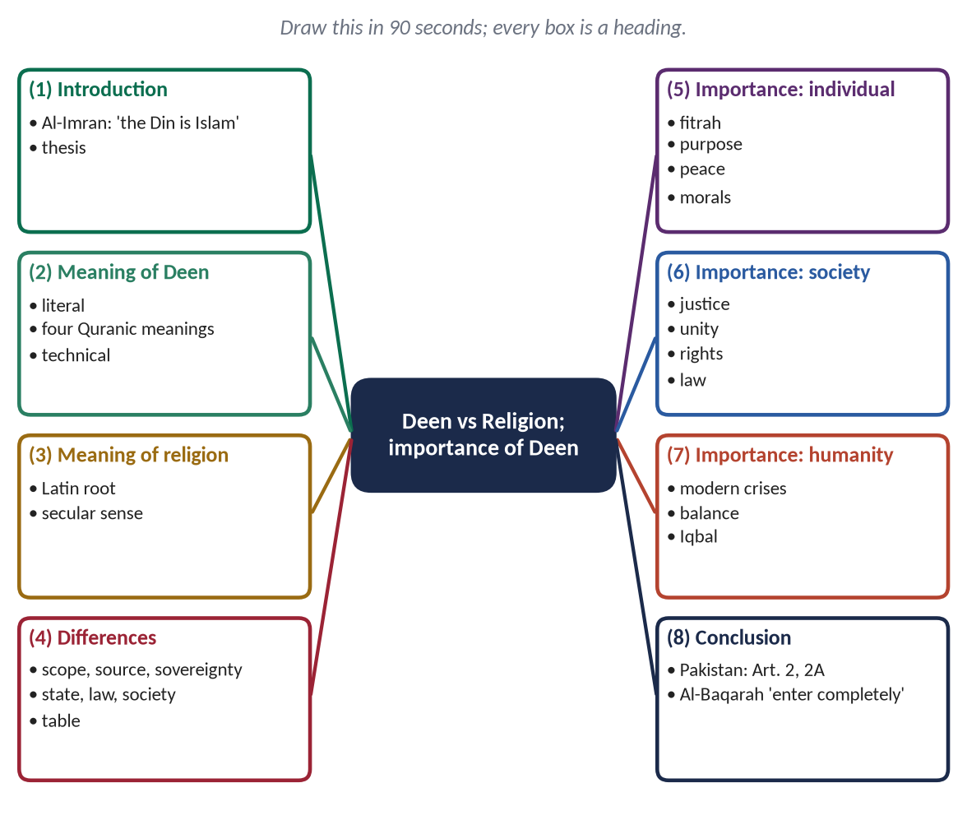
Figure 1 · The answer map: every branch is one numbered heading of the model answer below.

Decoding the question
- Two limbs: (a) the difference between Deen and religion — a comparison; (b) the importance of Deen in human life — a list of reasons 'with arguments', i.e. with evidence.
- Command words: 'What is the difference' = define both, then compare point by point; 'Describe … with arguments' = headed points, each proved.
- Weight: roughly 40% to the difference, 60% to the importance.

The model answer

(1) Introduction
✦ QURAN
﴿إِنَّ ٱلدِّينَ عِندَ ٱللَّهِ ٱلۡإِسۡلَٰمُۗ وَمَا ٱخۡتَلَفَ ٱلَّذِينَ أُوتُواْ ٱلۡكِتَٰبَ إِلَّا مِنۢ بَعۡدِ مَا جَآءَهُمُ ٱلۡعِلۡمُ بَغۡيَۢا بَيۡنَهُمۡۗ وَمَن يَكۡفُرۡ بِـَٔايَٰتِ ٱللَّهِ فَإِنَّ ٱللَّهَ سَرِيعُ ٱلۡحِسَابِ﴾
“Indeed, the religion in the sight of Allah is Islam. And those who were given the Scripture did not differ except after knowledge had come to them - out of jealous animosity between themselves. And whoever disbelieves in the verses of Allah, then indeed, Allah is swift in [taking] account.” (Aal-e-Imran, Quran)
➜ 'Indeed, the Din in the sight of Allah is Islam' — the Quran calls Islam a Din, not a religion in the narrow sense.

Every human society has had some form of religion. But the Quran uses a larger word for Islam: Din. The difference between the two words is not a matter of vocabulary; it is the difference between a corner of life and the whole of life. Religion, in its modern sense, is a private relationship between man and God; Din is a complete system that governs belief, worship, morality, family, economy, politics and law. This answer first explains the two concepts and their differences, and then argues why Din is necessary for the individual, for society and for humanity.

(2) The meaning of Deen

(i) Literal meaning
In Arabic, Din means authority, obedience, law and recompense.

(ii) The four meanings in the Quran
- (a) Sovereignty — 'Call upon Him, sincere to Him in Din' (Al-Mu'min).
- (b) Obedience — 'They were commanded only to worship Allah, sincere to Him in Din' (Al-Bayyinah).
- (c) Law and system — 'He could not take his brother within the din of the king' (Yusuf): din = the king's law.
- (d) Recompense — 'Master of the Day of Din' (Al-Fatihah).
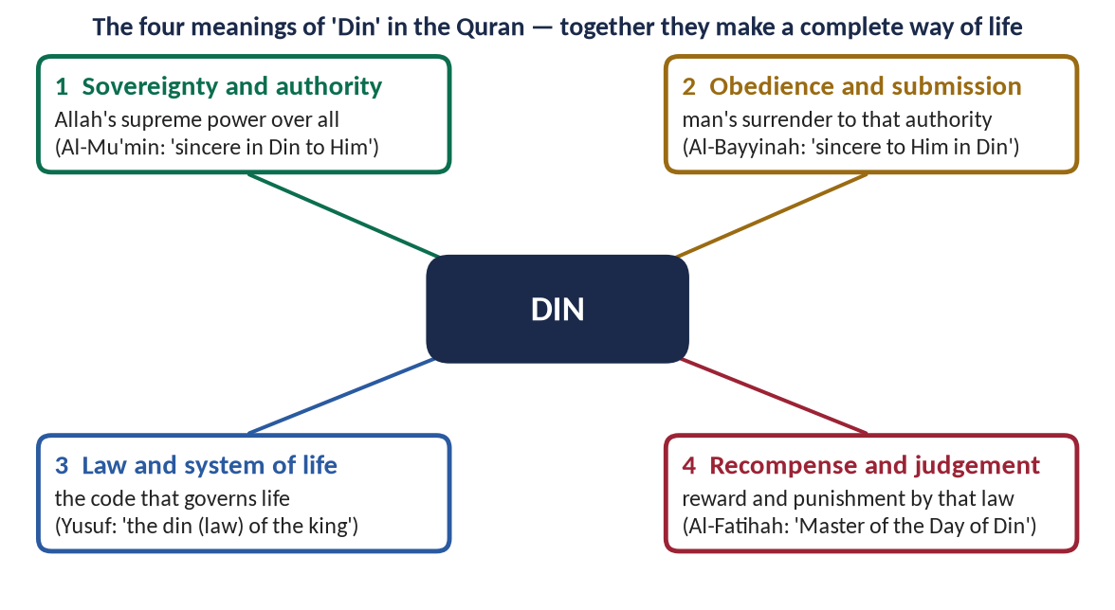
Figure 2 · The four meanings of Din in the Quran.

(iii) Technical meaning
Din is the complete system of life revealed by Allah: His sovereignty, man's obedience, His law, and recompense in the Hereafter.

(3) The meaning of religion

(i) The word
'Religion' comes from the Latin religare, 'to bind'. In modern Western usage, it means a set of beliefs, rituals and moral teachings about God or the sacred.

(ii) Its modern secular sense
After the conflicts between Church and state in Europe, religion came to be treated as a private matter, separate from politics, economics and law. The Arabic word nearest to this narrow sense is madhhab, not Din.

(4) The difference between Deen and religion
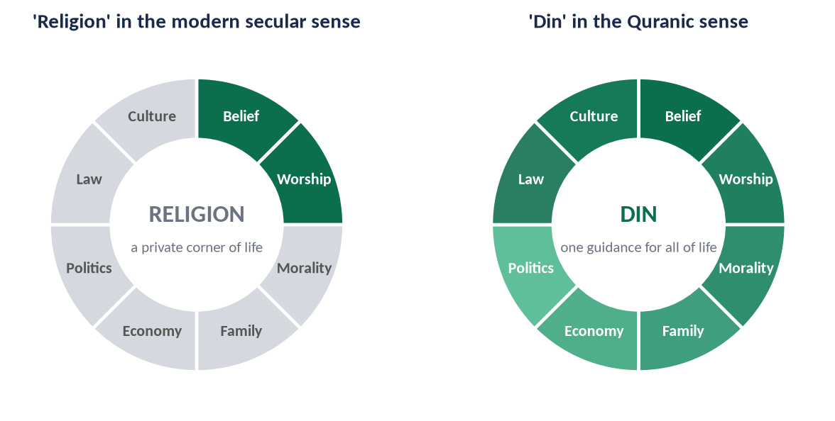
Figure 3 · Religion as one corner of life; Din as guidance for the whole of life.

(i) Scope
Religion covers belief and worship; Din covers the whole of life.
✦ QURAN
﴿يَـٰٓأَيُّهَا ٱلَّذِينَ ءَامَنُواْ ٱدۡخُلُواْ فِي ٱلسِّلۡمِ كَآفَّةٗ وَلَا تَتَّبِعُواْ خُطُوَٰتِ ٱلشَّيۡطَٰنِۚ إِنَّهُۥ لَكُمۡ عَدُوّٞ مُّبِينٞ﴾
“O you who have believed, enter into Islam completely [and perfectly] and do not follow the footsteps of Satan. Indeed, he is to you a clear enemy.” (Al-Baqarah, Quran)
➜ 'Enter into Islam completely' — a religion may be partial; a Din cannot.

(ii) Source
Religion may be built on custom, tradition or philosophy; Din rests on revelation.

(iii) Sovereignty
In secular religion, God reigns in the heart but the people or the state rule the world; in Din, sovereignty belongs to Allah and man is His vicegerent.

(iv) Relation with the state and law
Religion is separate from the state; Din guides the state and has its own law, the Shariah.
✦ QURAN
﴿شَرَعَ لَكُم مِّنَ ٱلدِّينِ مَا وَصَّىٰ بِهِۦ نُوحٗا وَٱلَّذِيٓ أَوۡحَيۡنَآ إِلَيۡكَ وَمَا وَصَّيۡنَا بِهِۦٓ إِبۡرَٰهِيمَ وَمُوسَىٰ وَعِيسَىٰٓۖ أَنۡ أَقِيمُواْ ٱلدِّينَ وَلَا تَتَفَرَّقُواْ فِيهِۚ …﴾
“He has ordained for you of the Din what He enjoined upon Nuh, what We have revealed to you, and what We enjoined upon Ibrahim, Musa and Isa: 'Establish the Din and do not be divided in it.'” (Ash-Shura, Quran)
➜ Allah ordained the same Din for Nuh, Ibrahim, Musa and Isa: 'establish the Din and do not be divided in it' — a Din is established in society, not only believed in the heart.

(v) Individual and society
Religion addresses the individual; Din addresses both the individual and the society.

(vi) This world and the next
Religion often concerns only the next world; Din balances this world and the Hereafter.
Point | Deen | Religion (modern sense)
Scope | Whole of life | Belief and ritual only
Source | Revelation | Tradition, custom, philosophy
Sovereignty | Allah | People or state
State and law | Guides both; has Shariah | Separate; no public law
Addressee | Individual and society | Individual
Worlds | This world and Hereafter | Mostly the other world

(vii) The practical proof: the life of the Prophet ﷺ
The Prophet ﷺ built the mosque and the state of Madinah in the same year. He led the prayer and the army, judged disputes, signed treaties and collected Zakat. His life is the living definition of Din.
✦ SCHOLARLY VIEW
Dr Muhammad Hamidullah · Introduction to Islam (FPSC reading list)
Dr Hamidullah points out that Islam does not divide life into the spiritual and the temporal; the Quran regulates both the relation of man with God and the relations of men with one another.
➜ A standard authority for the comprehensiveness of Din.

(5) The importance of Deen for the individual

(i) Din answers the call of human nature
✦ QURAN
﴿فَأَقِمۡ وَجۡهَكَ لِلدِّينِ حَنِيفٗاۚ فِطۡرَتَ ٱللَّهِ ٱلَّتِي فَطَرَ ٱلنَّاسَ عَلَيۡهَاۚ لَا تَبۡدِيلَ لِخَلۡقِ ٱللَّهِۚ ذَٰلِكَ ٱلدِّينُ ٱلۡقَيِّمُ وَلَٰكِنَّ أَكۡثَرَ ٱلنَّاسِ لَا يَعۡلَمُونَ﴾
“So direct your face toward the religion, inclining to truth. [Adhere to] the fitrah of Allah upon which He has created [all] people. No change should there be in the creation of Allah. That is the correct religion, but most of the people do not know.” (Ar-Rum, Quran)
➜ Din is the fitrah of Allah upon which He created mankind.

✦ HADITH
مَا مِنْ مَوْلُودٍ إِلَّا يُولَدُ عَلَى الْفِطْرَةِ
“Every child is born upon the fitrah.” (Al-Bukhari and Muslim)
➜ Belief in the Creator is natural; Din completes human nature.

(ii) Din gives life its purpose
✦ QURAN
﴿وَمَا خَلَقۡتُ ٱلۡجِنَّ وَٱلۡإِنسَ إِلَّا لِيَعۡبُدُونِ﴾
“And I did not create the jinn and mankind except to worship Me.” (Adh-Dhariyat, Quran)
➜ Man was created to worship Allah — to live his whole life in His obedience.

(iii) Din gives peace of heart
✦ QURAN
﴿ٱلَّذِينَ ءَامَنُواْ وَتَطۡمَئِنُّ قُلُوبُهُم بِذِكۡرِ ٱللَّهِۗ أَلَا بِذِكۡرِ ٱللَّهِ تَطۡمَئِنُّ ٱلۡقُلُوبُ﴾
“Those who have believed and whose hearts are assured by the remembrance of Allah. Unquestionably, by the remembrance of Allah hearts are assured.” (Ar-Ra'd, Quran)
➜ 'In the remembrance of Allah do hearts find rest.'

✦ QURAN
﴿وَمَنۡ أَعۡرَضَ عَن ذِكۡرِي فَإِنَّ لَهُۥ مَعِيشَةٗ ضَنكٗا وَنَحۡشُرُهُۥ يَوۡمَ ٱلۡقِيَٰمَةِ أَعۡمَىٰ﴾
“And whoever turns away from My remembrance - indeed, he will have a depressed life, and We will gather him on the Day of Resurrection blind.” (Taha, Quran)
➜ Whoever turns away from Allah's reminder will have a life of hardship — the inner emptiness of the modern age.

(iv) Din gives a fixed moral standard
Without Din, morality changes with fashion and majority vote. Din gives values that do not change.
✦ HADITH
إِنَّمَا بُعِثْتُ لِأُتَمِّمَ مَكَارِمَ الْأَخْلَاقِ
“I was sent only to perfect noble character.” (Al-Bayhaqi)
➜ The purpose of Din is to make good human beings.

(v) Din gives an inner check
Belief in Allah and the Hereafter makes a person honest when no one is watching — something no police force can achieve.

(6) The importance of Deen for society

(i) Justice
✦ QURAN
﴿لَقَدۡ أَرۡسَلۡنَا رُسُلَنَا بِٱلۡبَيِّنَٰتِ وَأَنزَلۡنَا مَعَهُمُ ٱلۡكِتَٰبَ وَٱلۡمِيزَانَ لِيَقُومَ ٱلنَّاسُ بِٱلۡقِسۡطِۖ وَأَنزَلۡنَا ٱلۡحَدِيدَ فِيهِ بَأۡسٞ شَدِيدٞ وَمَنَٰفِعُ لِلنَّاسِ وَلِيَعۡلَمَ ٱللَّهُ مَن يَنصُرُهُۥ وَرُسُلَهُۥ بِٱلۡغَيۡبِۚ إِنَّ ٱللَّهَ قَوِيٌّ عَزِيزٞ﴾
“We have already sent Our messengers with clear evidences and sent down with them the Scripture and the balance that the people may maintain [their affairs] in justice. And We sent down iron, wherein is great military might and benefits for the people, and so that Allah may make evident those who support Him and His messengers unseen. Indeed, Allah is Powerful and Exalted in Might.” (Al-Hadid, Quran)
➜ Messengers were sent with the Book and the Balance so that people may uphold justice — Din is the foundation of a just social order.

(ii) Unity and brotherhood
✦ QURAN
﴿وَٱعۡتَصِمُواْ بِحَبۡلِ ٱللَّهِ جَمِيعٗا وَلَا تَفَرَّقُواْۚ وَٱذۡكُرُواْ نِعۡمَتَ ٱللَّهِ عَلَيۡكُمۡ إِذۡ كُنتُمۡ أَعۡدَآءٗ فَأَلَّفَ بَيۡنَ قُلُوبِكُمۡ فَأَصۡبَحۡتُم بِنِعۡمَتِهِۦٓ إِخۡوَٰنٗا …﴾
“And hold firmly to the rope of Allah all together and do not become divided. Remember Allah's favour upon you: you were enemies, and He brought your hearts together, and by His favour you became brothers.” (Aal-e-Imran, Quran)
➜ 'Hold fast, all together, to the rope of Allah, and do not be divided' — Din made the warring tribes of Arabia brothers.

(iii) Rights and duties
Din fixes the rights of parents, spouses, children, neighbours, workers, the poor and even animals, and makes their fulfilment worship.

(iv) Law obeyed from within
A law obeyed out of faith is obeyed even where there is no policeman — this is why the society of Madinah needed so few punishments.

(7) The importance of Deen for humanity today

(i) The failure of life without Din
Materialism has produced wealth but also loneliness, family breakdown, depression and inequality.

(ii) The balance Din offers
✦ QURAN
﴿وَٱبۡتَغِ فِيمَآ ءَاتَىٰكَ ٱللَّهُ ٱلدَّارَ ٱلۡأٓخِرَةَۖ وَلَا تَنسَ نَصِيبَكَ مِنَ ٱلدُّنۡيَاۖ وَأَحۡسِن كَمَآ أَحۡسَنَ ٱللَّهُ إِلَيۡكَۖ وَلَا تَبۡغِ ٱلۡفَسَادَ فِي ٱلۡأَرۡضِۖ إِنَّ ٱللَّهَ لَا يُحِبُّ ٱلۡمُفۡسِدِينَ﴾
“But seek, through that which Allah has given you, the home of the Hereafter; and [yet], do not forget your share of the world. And do good as Allah has done good to you. And desire not corruption in the land. Indeed, Allah does not like corrupters.” (Al-Qasas, Quran)
➜ Seek the Hereafter, but do not forget your share of this world — Din rejects both monasticism and materialism.

✦ SCHOLARLY VIEW
Allama Muhammad Iqbal · The Reconstruction of Religious Thought in Islam
Iqbal argues that humanity needs a spiritual interpretation of the universe, the spiritual emancipation of the individual, and basic principles of universal import to direct the evolution of society on a spiritual basis — and only a Din can provide them.
➜ The modern case for Din in one sentence.

PAKISTAN ANGLE
Pakistan was founded on the concept of Din: Article 2 makes Islam the State religion; Article 2A (the Objectives Resolution) declares that sovereignty belongs to Allah alone and that authority is a sacred trust exercised within the limits He has prescribed.

(8) Conclusion
Religion, in the modern sense, is a room in the house of life; Din is the house itself. Islam includes everything that religion means — faith, prayer and love of God — but it does not stop there: it goes on into the family, the market, the court and the state. That is why Din is essential: it completes human nature, gives life purpose and peace, supplies fixed moral values, builds a just and united society, and offers humanity a balance that materialism cannot. The Quran's command sums up the whole answer:
✦ QURAN
﴿يَـٰٓأَيُّهَا ٱلَّذِينَ ءَامَنُواْ ٱدۡخُلُواْ فِي ٱلسِّلۡمِ كَآفَّةٗ وَلَا تَتَّبِعُواْ خُطُوَٰتِ ٱلشَّيۡطَٰنِۚ إِنَّهُۥ لَكُمۡ عَدُوّٞ مُّبِينٞ﴾
“O you who have believed, enter into Islam completely [and perfectly] and do not follow the footsteps of Satan. Indeed, he is to you a clear enemy.” (Al-Baqarah, Quran)
➜ 'O you who believe, enter into Islam completely, and do not follow the footsteps of Satan.'

Why this answer scores
- Both limbs are answered, in proportion, under headings that repeat the question's words.
- The difference is shown three ways: point-by-point headings, a figure, and a table.
- Every point of 'importance' carries a verse or hadith — the examiner asked for 'arguments'.
- The Pakistan angle and Iqbal give depth without leaving the question.

Answer 2 · The Importance of Deen as the Doctrine of Life (CSS 2022)
THE QUESTION · CSS 2022 · Q8 · 20 marks
Describe the importance of Deen (Doctrine of life) in human life. Differentiate between Deen and Religions.

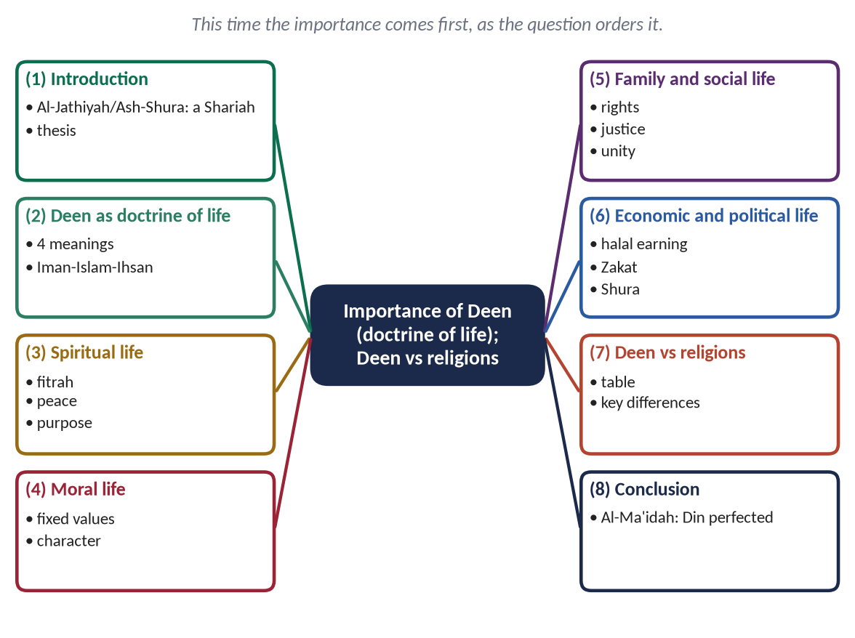
Figure 4 · The answer map: every branch is one numbered heading of the model answer below.

Decoding the question
- The 2022 question reverses the order of 2016: importance first, difference second. Follow the order the examiner gives.
- The phrase 'doctrine of life' is the examiner's own translation of Din. Build the answer around it: Din is a doctrine that governs every department of life — so organise the importance by departments of life (spiritual, moral, family, social, economic, political).
- 'Religions' (plural): compare Din with religion as it is commonly understood in the world's traditions and in secular thought — without disrespecting any faith.

The model answer

(1) Introduction
✦ QURAN
﴿ثُمَّ جَعَلۡنَٰكَ عَلَىٰ شَرِيعَةٖ مِّنَ ٱلۡأَمۡرِ فَٱتَّبِعۡهَا وَلَا تَتَّبِعۡ أَهۡوَآءَ ٱلَّذِينَ لَا يَعۡلَمُونَ﴾
“Then We put you, [O Muhammad], on an ordained way concerning the matter [of religion]; so follow it and do not follow the inclinations of those who do not know.” (Al-Jathiyah, Quran)
➜ 'Then We put you on a clear way (Shariah) of the matter; so follow it, and do not follow the desires of those who do not know.'

The examiner's phrase is exact: Din is a doctrine of life. It is not a set of rituals added to life, but a doctrine that shapes all of life — how a person believes, prays, thinks, trades, marries, governs and dies. In the Hadith of Jibril, the Prophet ﷺ called belief (Iman), practice (Islam) and excellence (Ihsan) together 'your Din'. This answer shows its importance in each department of human life, and then distinguishes Din from religion as the world commonly understands it.

(2) Deen as a doctrine of life

(i) The four meanings make a system
Din in the Quran means sovereignty (of Allah), obedience (of man), law (the Shariah) and recompense (the Hereafter). Together they form a complete doctrine: an authority, a subject, a law and a sanction.

(ii) The three levels of Din
✦ HADITH
فَإِنَّهُ جِبْرِيلُ أَتَاكُمْ يُعَلِّمُكُمْ دِينَكُمْ
“That was Jibril; he came to teach you your Din.” (Muslim)
➜ Iman, Islam and Ihsan together are the Din.

(3) Importance in the spiritual life

(i) Satisfying the fitrah
✦ QURAN
﴿فَأَقِمۡ وَجۡهَكَ لِلدِّينِ حَنِيفٗاۚ فِطۡرَتَ ٱللَّهِ ٱلَّتِي فَطَرَ ٱلنَّاسَ عَلَيۡهَاۚ لَا تَبۡدِيلَ لِخَلۡقِ ٱللَّهِۚ ذَٰلِكَ ٱلدِّينُ ٱلۡقَيِّمُ وَلَٰكِنَّ أَكۡثَرَ ٱلنَّاسِ لَا يَعۡلَمُونَ﴾
“So direct your face toward the religion, inclining to truth. [Adhere to] the fitrah of Allah upon which He has created [all] people. No change should there be in the creation of Allah. That is the correct religion, but most of the people do not know.” (Ar-Rum, Quran)
➜ Din is the fitrah of Allah upon which He created mankind.

(ii) Peace of the heart
✦ QURAN
﴿ٱلَّذِينَ ءَامَنُواْ وَتَطۡمَئِنُّ قُلُوبُهُم بِذِكۡرِ ٱللَّهِۗ أَلَا بِذِكۡرِ ٱللَّهِ تَطۡمَئِنُّ ٱلۡقُلُوبُ﴾
“Those who have believed and whose hearts are assured by the remembrance of Allah. Unquestionably, by the remembrance of Allah hearts are assured.” (Ar-Ra'd, Quran)
➜ In the remembrance of Allah hearts find rest.

(iii) Meaning and purpose
✦ QURAN
﴿ٱلَّذِي خَلَقَ ٱلۡمَوۡتَ وَٱلۡحَيَوٰةَ لِيَبۡلُوَكُمۡ أَيُّكُمۡ أَحۡسَنُ عَمَلٗاۚ وَهُوَ ٱلۡعَزِيزُ ٱلۡغَفُورُ﴾
“[He] who created death and life to test you [as to] which of you is best in deed - and He is the Exalted in Might, the Forgiving.” (Al-Mulk, Quran)
➜ He created death and life to test which of you is best in deeds.

(4) Importance in the moral life

(i) Fixed and universal values
Din gives values that are true for all people at all times: truth, justice, chastity, mercy, trust.
✦ QURAN
﴿إِنَّ ٱللَّهَ يَأۡمُرُ بِٱلۡعَدۡلِ وَٱلۡإِحۡسَٰنِ وَإِيتَآيِٕ ذِي ٱلۡقُرۡبَىٰ وَيَنۡهَىٰ عَنِ ٱلۡفَحۡشَآءِ وَٱلۡمُنكَرِ وَٱلۡبَغۡيِۚ يَعِظُكُمۡ لَعَلَّكُمۡ تَذَكَّرُونَ﴾
“Indeed, Allah orders justice and good conduct and giving to relatives and forbids immorality and bad conduct and oppression. He admonishes you that perhaps you will be reminded.” (An-Nahl, Quran)
➜ Allah commands justice, excellence and giving to relatives, and forbids indecency, evil and oppression — the moral charter of Din.

(ii) The motive to be good
✦ HADITH
أَكْمَلُ الْمُؤْمِنِينَ إِيمَانًا أَحْسَنُهُمْ خُلُقًا
“The most complete of the believers in faith is the one with the best character.” (Abu Dawud and Al-Tirmidhi)
➜ Din makes character the measure of faith.

(5) Importance in family and social life

(i) A stable family
Din defines marriage as a covenant of love and mercy, and fixes the rights of spouses, parents and children.
✦ QURAN
﴿وَمِنۡ ءَايَٰتِهِۦٓ أَنۡ خَلَقَ لَكُم مِّنۡ أَنفُسِكُمۡ أَزۡوَٰجٗا لِّتَسۡكُنُوٓاْ إِلَيۡهَا وَجَعَلَ بَيۡنَكُم مَّوَدَّةٗ وَرَحۡمَةًۚ إِنَّ فِي ذَٰلِكَ لَأٓيَٰتٖ لِّقَوۡمٖ يَتَفَكَّرُونَ﴾
“And of His signs is that He created for you from yourselves mates that you may find tranquillity in them; and He placed between you affection and mercy. Indeed in that are signs for a people who give thought.” (Ar-Rum, Quran)
➜ He created for you mates that you may find tranquillity in them, and placed love and mercy between you.

(ii) Rights of people
✦ HADITH
لَا يُؤْمِنُ أَحَدُكُمْ حَتَّى يُحِبَّ لِأَخِيهِ مَا يُحِبُّ لِنَفْسِهِ
“None of you truly believes until he loves for his brother what he loves for himself.” (Al-Bukhari and Muslim)
➜ Din turns social ethics into faith.

(iii) Equality and brotherhood
✦ QURAN
﴿يَـٰٓأَيُّهَا ٱلنَّاسُ إِنَّا خَلَقۡنَٰكُم مِّن ذَكَرٖ وَأُنثَىٰ وَجَعَلۡنَٰكُمۡ شُعُوبٗا وَقَبَآئِلَ لِتَعَارَفُوٓاْۚ إِنَّ أَكۡرَمَكُمۡ عِندَ ٱللَّهِ أَتۡقَىٰكُمۡۚ إِنَّ ٱللَّهَ عَلِيمٌ خَبِيرٞ﴾
“O mankind, indeed We have created you from male and female and made you peoples and tribes that you may know one another. Indeed, the most noble of you in the sight of Allah is the most righteous of you. Indeed, Allah is Knowing and Acquainted.” (Al-Hujurat, Quran)
➜ No superiority of race or tribe; the most honoured is the most righteous.

(6) Importance in economic and political life

(i) Lawful earning and fair distribution
Din forbids riba, hoarding and cheating, and makes Zakat a pillar of faith, so that wealth circulates.
✦ QURAN
﴿… كَيۡ لَا يَكُونَ دُولَةَۢ بَيۡنَ ٱلۡأَغۡنِيَآءِ مِنكُمۡۚ …﴾
“… so that it does not circulate only among the rich among you.” (Al-Hashr, Quran)
➜ So that wealth does not circulate only among the rich among you.

(ii) Just government
Din makes power a trust, consultation a duty and justice the purpose of the state.
✦ QURAN
﴿وَٱلَّذِينَ ٱسۡتَجَابُواْ لِرَبِّهِمۡ وَأَقَامُواْ ٱلصَّلَوٰةَ وَأَمۡرُهُمۡ شُورَىٰ بَيۡنَهُمۡ وَمِمَّا رَزَقۡنَٰهُمۡ يُنفِقُونَ﴾
“And those who have responded to their lord and established prayer and whose affair is [determined by] consultation among themselves, and from what We have provided them, they spend.” (Ash-Shura, Quran)
➜ Believers conduct their affairs by consultation among themselves.

✦ QURAN
﴿إِنَّ ٱللَّهَ يَأۡمُرُكُمۡ أَن تُؤَدُّواْ ٱلۡأَمَٰنَٰتِ إِلَىٰٓ أَهۡلِهَا وَإِذَا حَكَمۡتُم بَيۡنَ ٱلنَّاسِ أَن تَحۡكُمُواْ بِٱلۡعَدۡلِۚ إِنَّ ٱللَّهَ نِعِمَّا يَعِظُكُم بِهِۦٓۗ إِنَّ ٱللَّهَ كَانَ سَمِيعَۢا بَصِيرٗا﴾
“Indeed, Allah commands you to render trusts to whom they are due and when you judge between people to judge with justice. Excellent is that which Allah instructs you. Indeed, Allah is ever Hearing and Seeing.” (An-Nisa, Quran)
➜ Render trusts to those to whom they are due, and judge with justice.

(7) The difference between Deen and religions

(i) A complete doctrine, not a department
Most religious traditions today, and all secular thought, treat religion as one department of life. Din is the doctrine that governs all departments.

(ii) Revealed, not constructed
Din is revealed by Allah; many religious traditions have grown by human addition over centuries.

(iii) Preserved sources
The Quran is preserved word for word (Al-Hijr: 'We will guard it'); Din therefore has a fixed and knowable standard.

(iv) A law and a state
Din has a public law (Shariah) and principles of government; secular religion has neither.

(v) Balance
Din balances this world and the Hereafter, the individual and the society, rights and duties.
Point | Deen (doctrine of life) | Religion (common and secular sense)
Coverage | All departments of life | Belief, worship, personal morality
Origin | Revelation, preserved | Tradition, often changed by human hands
Law | Shariah: public and private | Personal ethics only
Politics | Sovereignty of Allah; Shura; justice | Separated from politics
World-view | This world and the Hereafter | Mostly the hereafter or inner comfort
Freedom of others | 'No compulsion in religion' (Al-Baqarah) | Varies

(vi) A fair word
Din does not reject what is good in religion — faith, prayer, love of God; it completes it. And because the Quran commands 'no compulsion in religion', a Din-based society protects the faith of others.

(8) Conclusion
Din is the doctrine of life because it answers every question life asks — spiritual, moral, social, economic and political — from one source and with one purpose. That is its importance; and that is its difference from religion, which answers only some of them. It was completed on the Day of Arafah:
✦ QURAN
﴿… ٱلۡيَوۡمَ أَكۡمَلۡتُ لَكُمۡ دِينَكُمۡ وَأَتۡمَمۡتُ عَلَيۡكُمۡ نِعۡمَتِي وَرَضِيتُ لَكُمُ ٱلۡإِسۡلَٰمَ دِينٗاۚ …﴾
“This day I have perfected for you your religion, completed My favour upon you, and approved for you Islam as your way of life.” (Al-Ma'idah, Quran)
➜ A perfected doctrine of life — the final proof of Din's importance.

Why this answer scores
- It follows the examiner's order and his own phrase ('doctrine of life') — the importance is organised by departments of life.
- It avoids repeating the 2016 answer mechanically: same evidence bank, new structure for the new wording.
- It is respectful of other religions while making the distinction clear.

Answer 3 · The Supremacy of Wahi (CSS 2015)
THE QUESTION · CSS 2015 · Q7 · 16 marks (old scheme)
Argue for supremacy of 'Wahi' as the solution of human problems against other sources of knowledge.

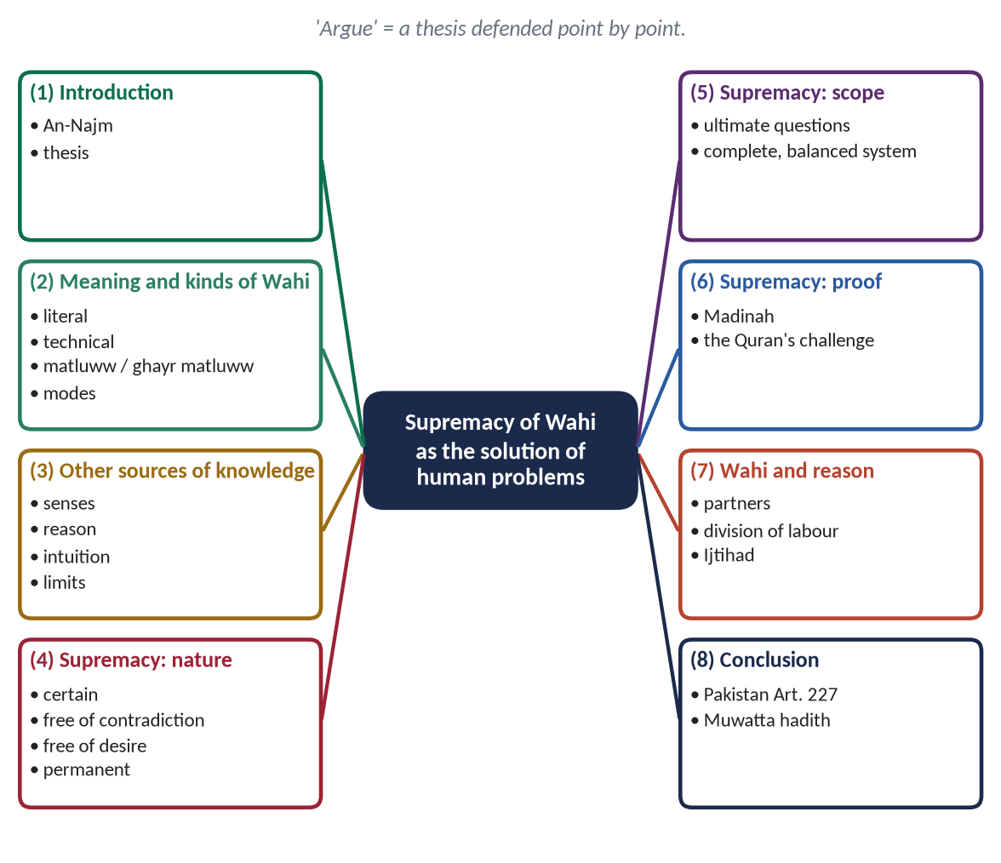
Figure 5 · The answer map: every branch is one numbered heading of the model answer below.

Decoding the question
- 'Argue for' = take a clear side and defend it. The thesis: Wahi is supreme because it is the only source that is certain, complete, unchanging and free from desire.
- 'As the solution of human problems' = show Wahi solving real problems (moral confusion, injustice, economic crises), not only theory.
- 'Against other sources of knowledge' = name the other sources (senses, reason, intuition, science, experience) and show their limits — fairly.

The model answer

(1) Introduction
✦ QURAN
﴿وَمَا يَنطِقُ عَنِ ٱلۡهَوَىٰٓ ۝ إِنۡ هُوَ إِلَّا وَحۡيٞ يُوحَىٰ﴾
“Nor does he speak from [his own] inclination. It is not but a revelation revealed.” (An-Najm, Quran)
➜ The Prophet ﷺ does not speak from his own desire; it is only a revelation revealed.

Man has always sought knowledge through his senses, his reason and his experience. These are gifts of Allah, and Islam honours them. But they are limited, and they disagree; they tell us how things work but not why we exist or what we ought to do. Wahi — knowledge revealed by the Creator — is the only source that answers these questions with certainty. This answer argues that Wahi is supreme as the solution of human problems, while showing that it guides reason rather than abolishing it.

(2) The meaning and kinds of Wahi

(i) Literal and technical meaning
Literally, Wahi is a quick, hidden communication. Technically, it is the message of Allah conveyed to His Prophets to guide mankind.

(ii) The two kinds
- Wahi Matluww — the Quran, recited, its words and meanings from Allah.
- Wahi Ghayr Matluww — the Sunnah, its meaning from Allah, its words from the Prophet ﷺ.

(iii) The modes
✦ QURAN
﴿وَمَا كَانَ لِبَشَرٍ أَن يُكَلِّمَهُ ٱللَّهُ إِلَّا وَحۡيًا أَوۡ مِن وَرَآيِٕ حِجَابٍ أَوۡ يُرۡسِلَ رَسُولٗا فَيُوحِيَ بِإِذۡنِهِۦ مَا يَشَآءُۚ إِنَّهُۥ عَلِيٌّ حَكِيمٞ﴾
“And it is not for any human being that Allah should speak to him except by revelation or from behind a partition or that He sends a messenger to reveal, by His permission, what He wills. Indeed, He is Most High and Wise.” (Ash-Shura, Quran)
➜ Allah speaks to man by inspiration, or from behind a veil, or by sending a messenger — the three modes of revelation.

(3) The other sources of knowledge and their limits
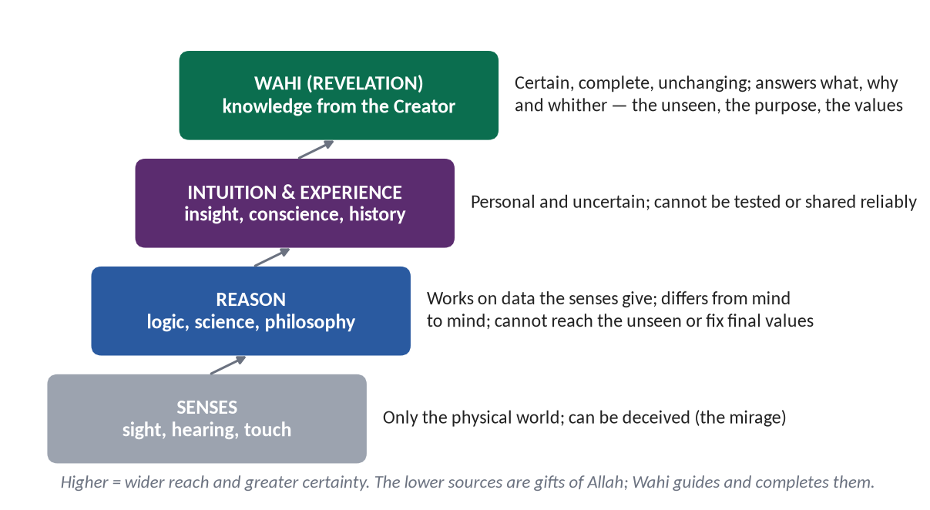
Figure 6 · The sources of human knowledge, their reach and their limits.

(i) The senses
They reach only the physical world and can be deceived (the mirage, the stick that looks bent in water).

(ii) Reason
- It depends on the data of the senses.
- It differs from mind to mind and age to age.
- It is led by desire and interest.
- It cannot reach the unseen or fix final values.
✦ QURAN
﴿وَيَسۡـَٔلُونَكَ عَنِ ٱلرُّوحِۖ قُلِ ٱلرُّوحُ مِنۡ أَمۡرِ رَبِّي وَمَآ أُوتِيتُم مِّنَ ٱلۡعِلۡمِ إِلَّا قَلِيلٗا﴾
“And they ask you, [O Muhammad], about the soul. Say, "The soul is of the affair of my Lord. And mankind have not been given of knowledge except a little.” (Al-Isra, Quran)
➜ 'You have been given of knowledge only a little.'

(iii) Intuition and experience
Personal and uncertain; they cannot be tested or imposed on others.

(iv) Science
Science is organised observation and reason. It is powerful in its field, but its conclusions are provisional and it cannot answer questions of meaning and value.

(4) The supremacy of Wahi — its nature

(i) Certainty against conjecture
✦ QURAN
﴿وَمَا يَتَّبِعُ أَكۡثَرُهُمۡ إِلَّا ظَنًّاۚ إِنَّ ٱلظَّنَّ لَا يُغۡنِي مِنَ ٱلۡحَقِّ شَيۡـًٔاۚ إِنَّ ٱللَّهَ عَلِيمُۢ بِمَا يَفۡعَلُونَ﴾
“And most of them follow not except assumption. Indeed, assumption avails not against the truth at all. Indeed, Allah is Knowing of what they do.” (Yunus, Quran)
➜ Most of them follow nothing but assumption; assumption is of no use against the truth.

(ii) Freedom from contradiction
✦ QURAN
﴿أَفَلَا يَتَدَبَّرُونَ ٱلۡقُرۡءَانَۚ وَلَوۡ كَانَ مِنۡ عِندِ غَيۡرِ ٱللَّهِ لَوَجَدُواْ فِيهِ ٱخۡتِلَٰفٗا كَثِيرٗا﴾
“Then do they not reflect upon the Qur'an? If it had been from [any] other than Allah, they would have found within it much contradiction.” (An-Nisa, Quran)
➜ Had it been from other than Allah, they would have found in it much contradiction.

(iii) Freedom from desire and interest
Human legislators — kings, classes, parties, corporations — legislate in their own interest. Wahi comes from the Lord of all, who needs nothing from anyone.

(iv) Permanence of values
Human morality has reversed itself many times; Wahi's values do not bend.
- Alcohol: the United States prohibited it by constitutional amendment in 1920 and repealed the prohibition in 1933; the Quran's prohibition stands.
- Interest: the global financial crisis of 2008 showed the danger of the debt economy that the Quran forbade (Al-Baqarah: 'Allah has permitted trade and forbidden riba').
- Racism: 'scientific' racism was respectable in the early twentieth century; the Quran had declared equality in the seventh (Al-Hujurat).

(5) The supremacy of Wahi — its scope

(i) It answers the ultimate questions
Where did I come from (Tawhid)? Why am I here (Risalat)? Where am I going (Akhirah)? No other source can answer these with certainty.

(ii) It gives a complete and balanced system
Capitalism solved production and created inequality; socialism promised equality and destroyed freedom. Wahi balances the individual and society, the body and the soul, rights and duties.
✦ QURAN
﴿وَيَوۡمَ نَبۡعَثُ فِي كُلِّ أُمَّةٖ شَهِيدًا عَلَيۡهِم مِّنۡ أَنفُسِهِمۡۖ وَجِئۡنَا بِكَ شَهِيدًا عَلَىٰ هَـٰٓؤُلَآءِۚ وَنَزَّلۡنَا عَلَيۡكَ ٱلۡكِتَٰبَ تِبۡيَٰنٗا لِّكُلِّ شَيۡءٖ وَهُدٗى وَرَحۡمَةٗ وَبُشۡرَىٰ لِلۡمُسۡلِمِينَ﴾
“And [mention] the Day when We will resurrect among every nation a witness over them from themselves. And We will bring you, [O Muhammad], as a witness over your nation. And We have sent down to you the Book as clarification for all things and as guidance and mercy and good tidings for the Muslims.” (An-Nahl, Quran)
➜ The Book was revealed as a clarification of all things, and as guidance, mercy and good news.

(6) The supremacy of Wahi — its proof

(i) The proof of history
In twenty-three years Wahi turned the scattered tribes of Arabia — without state, law or learning — into the most just society of their time and the teachers of the world.

(ii) The Quran's challenge
✦ QURAN
﴿قُل لَّئِنِ ٱجۡتَمَعَتِ ٱلۡإِنسُ وَٱلۡجِنُّ عَلَىٰٓ أَن يَأۡتُواْ بِمِثۡلِ هَٰذَا ٱلۡقُرۡءَانِ لَا يَأۡتُونَ بِمِثۡلِهِۦ وَلَوۡ كَانَ بَعۡضُهُمۡ لِبَعۡضٖ ظَهِيرٗا﴾
“Say, "If mankind and the jinn gathered in order to produce the like of this Qur'an, they could not produce the like of it, even if they were to each other assistants.” (Al-Isra, Quran)
➜ If mankind and jinn gathered to produce the like of this Quran, they could not.

(iii) The testimony of a master of reason
✦ SCHOLARLY VIEW
Imam Al-Ghazali · Al-Munqidh min al-Dalal
Ghazali, the greatest philosopher-theologian of his age, describes how doubt about the senses and reason left him unable to teach or speak, and how he was restored not by a proof but by 'a light that Allah cast into the heart'. He concluded that prophecy is a level of knowledge above reason.
➜ A master of reason testifies to its limits.

(7) Wahi and reason: supremacy, not hostility

(i) Islam honours reason
The Quran asks again and again, 'Do you not reason? Do you not reflect?'

(ii) The division of labour
✦ HADITH
أَنْتُمْ أَعْلَمُ بِأَمْرِ دُنْيَاكُمْ
“You know better the affairs of your world.” (Muslim)
➜ In technical worldly matters, experience decides; in belief, worship and moral law, Wahi decides.

(iii) The rule of priority
Where Wahi speaks clearly, reason follows; where it is silent, reason works within its principles — the method of Ijtihad.
✦ QURAN
﴿يَـٰٓأَيُّهَا ٱلَّذِينَ ءَامَنُوٓاْ أَطِيعُواْ ٱللَّهَ وَأَطِيعُواْ ٱلرَّسُولَ وَأُوْلِي ٱلۡأَمۡرِ مِنكُمۡۖ فَإِن تَنَٰزَعۡتُمۡ فِي شَيۡءٖ فَرُدُّوهُ إِلَى ٱللَّهِ وَٱلرَّسُولِ إِن كُنتُمۡ تُؤۡمِنُونَ بِٱللَّهِ وَٱلۡيَوۡمِ ٱلۡأٓخِرِۚ ذَٰلِكَ خَيۡرٞ وَأَحۡسَنُ تَأۡوِيلًا﴾
“O you who have believed, obey Allah and obey the Messenger and those in authority among you. And if you disagree over anything, refer it to Allah and the Messenger, if you should believe in Allah and the Last Day. That is the best [way] and best in result.” (An-Nisa, Quran)
➜ If you disagree over anything, refer it to Allah and the Messenger.

PAKISTAN ANGLE
Article 227 of the Constitution: no law shall be enacted which is repugnant to the Injunctions of Islam as laid down in the Holy Quran and Sunnah. The state itself accepts Wahi as the supreme standard of law.

(8) Conclusion
The senses see, reason connects, experience remembers — but only Wahi knows. It is supreme because it comes from the Creator of man; because it is certain, consistent, unchanging and free from interest; because it answers the questions that matter most; and because history has proved its power to transform human life. Reason is not dismissed; it is given a guide.
✦ HADITH
تَرَكْتُ فِيكُمْ أَمْرَيْنِ لَنْ تَضِلُّوا مَا تَمَسَّكْتُمْ بِهِمَا: كِتَابَ اللَّهِ وَسُنَّةَ نَبِيِّهِ
“I have left among you two things; you will never go astray as long as you hold fast to them: the Book of Allah and the Sunnah of His Prophet.” (Muwatta Imam Malik)
➜ Wahi is the guarantee against going astray.

Why this answer scores
- It argues, as commanded: a thesis in the introduction, three groups of proofs (nature, scope, history), and an answer to the objection that Islam rejects reason.
- It is fair to the other sources — which makes the case for Wahi more convincing.
- Its examples (alcohol, the 2008 crisis, racism) make the argument concrete and modern.

Answer 4 · Tauheed and Its Impact on the Individual and Society (CSS 2019)
THE QUESTION · CSS 2019 · Q2 · 20 marks
Define Tauheed. What is its impact on individual life and the society? Elaborate.

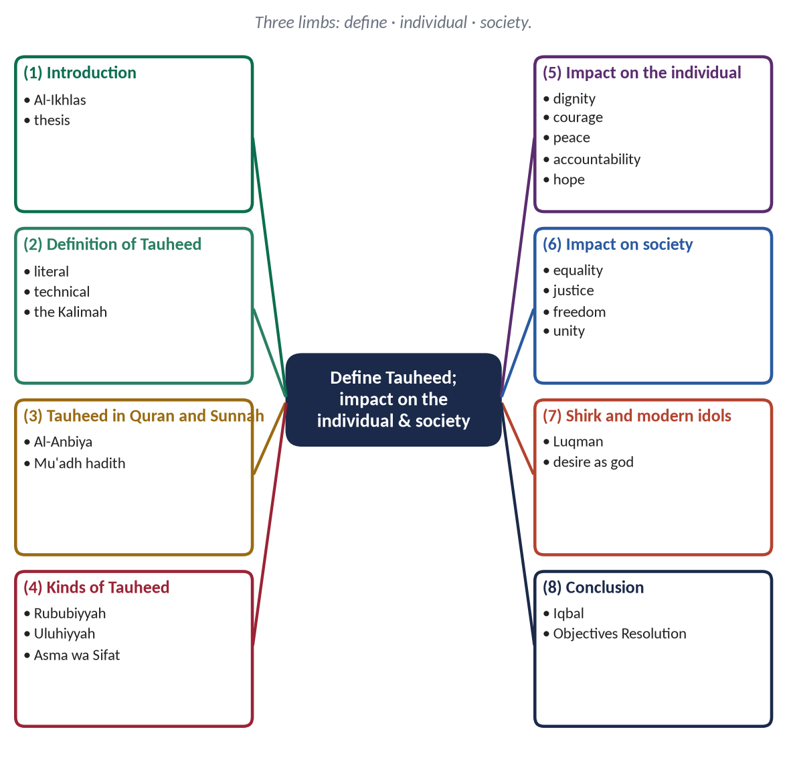
Figure 7 · The answer map: every branch is one numbered heading of the model answer below.

Decoding the question
- 'Define' — literal meaning, technical meaning, and the evidence; add the kinds, because a definition of Tauheed is incomplete without them.
- 'Impact on individual life' and 'the society' — two separate headed sections of roughly equal weight, each with 6–8 sub-headings.
- 'Elaborate' — each impact must be explained and proved, not listed.

The model answer

(1) Introduction
✦ QURAN
﴿قُلۡ هُوَ ٱللَّهُ أَحَدٌ ۝ ٱللَّهُ ٱلصَّمَدُ ۝ لَمۡ يَلِدۡ وَلَمۡ يُولَدۡ ۝ وَلَمۡ يَكُن لَّهُۥ كُفُوًا أَحَدُۢ﴾
“Say, "He is Allah, [who is] One. Allah, the Eternal Refuge. He neither begets nor is born. Nor is there to Him any equivalent.” (Al-Ikhlas, Quran)
➜ 'Say: He is Allah, the One; Allah, the Eternal Refuge; He neither begets nor is born; nor is there to Him any equivalent.'

Tauheed is the first article of faith, the first words a Muslim hears at birth and the last he hopes to say at death. It is the message of every Prophet and the foundation of the whole Din. But Tauheed is not only a belief about God; it is a belief about man and society. When a person accepts that there is no god but Allah, he is freed from every false master, and when a society accepts it, no human being can claim to be its god. This answer defines Tauheed and then shows its impact on the individual and on society.

(2) Definition of Tauheed

(i) Literal meaning
Tauheed comes from wahhada — to make one, to declare one.

(ii) Technical meaning
Tauheed is the belief that Allah is One in His essence, His attributes, His lordship and His right to worship, without partner, equal or rival — and living according to that belief.

(iii) The Kalimah: negation and affirmation
'La ilaha illallah' first negates every false god (la ilaha) and then affirms Allah alone (illallah). Tauheed begins with freedom from everything else.

(3) Tauheed in the Quran and Sunnah
✦ QURAN
﴿وَمَآ أَرۡسَلۡنَا مِن قَبۡلِكَ مِن رَّسُولٍ إِلَّا نُوحِيٓ إِلَيۡهِ أَنَّهُۥ لَآ إِلَٰهَ إِلَّآ أَنَا۠ فَٱعۡبُدُونِ﴾
“And We sent not before you any messenger except that We revealed to him that, "There is no deity except Me, so worship Me.” (Al-Anbiya, Quran)
➜ Every messenger was told: there is no god but Me, so worship Me — Tauheed is the common message of all Prophets.

✦ HADITH
حَقُّ اللَّهِ عَلَى الْعِبَادِ أَنْ يَعْبُدُوهُ وَلَا يُشْرِكُوا بِهِ شَيْئًا
“The right of Allah upon His servants is that they worship Him and associate nothing with Him.” (Al-Bukhari and Muslim)
➜ Tauheed is the first right of Allah over mankind.

(4) Kinds of Tauheed
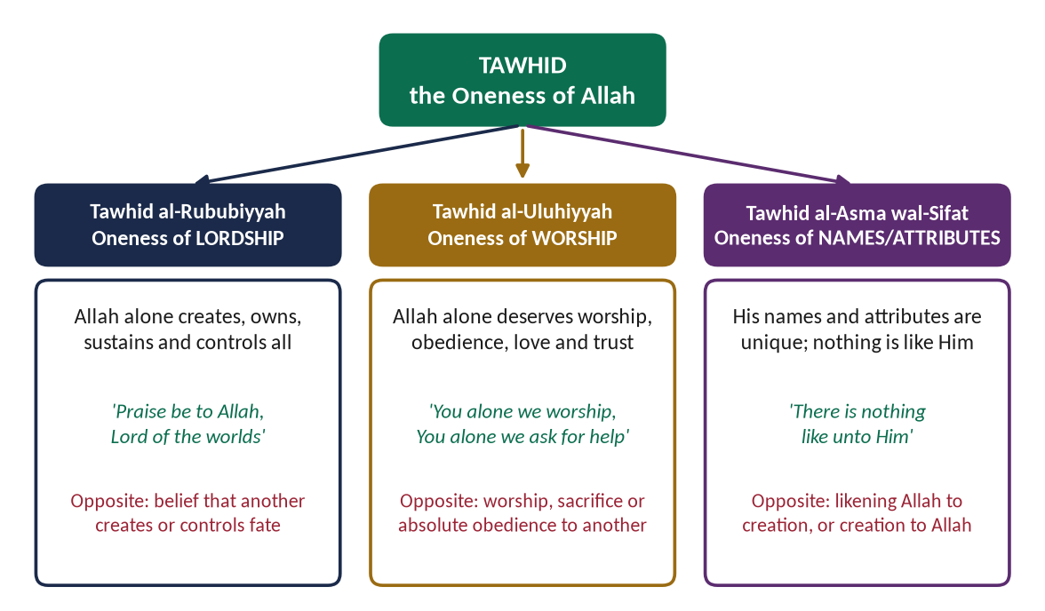
Figure 8 · The three kinds of Tauheed.

(i) Tauheed al-Rububiyyah — Oneness of Lordship
Allah alone creates, owns, sustains and controls everything (Az-Zumar: 'Allah is the Creator of all things').

(ii) Tauheed al-Uluhiyyah — Oneness of Worship
Allah alone deserves worship, obedience, trust and love (Al-Fatihah: 'You alone we worship').

(iii) Tauheed al-Asma wal-Sifat — Oneness of Names and Attributes
His names and attributes are unique; nothing resembles Him (Ash-Shura: 'There is nothing like unto Him').

(5) Impact of Tauheed on individual life

(i) Dignity and self-respect
A believer bows to no king, no rich man, no idol — only to Allah.
✦ SCHOLARLY VIEW
Allama Muhammad Iqbal · Zarb-e-Kalim
In the couplet 'Yeh ek sajda jise tu giran samajhta hai, hazar sajdon se deta hai admi ko najat', Iqbal says that the one prostration to Allah which man finds heavy frees him from a thousand prostrations to others.
➜ Tauheed is liberation of the human spirit.

- (a) Example: Hazrat Bilal (RA), a tortured slave, answered his master with 'Ahad, Ahad' — One, One.

(ii) Courage and fearlessness
✦ HADITH
وَاعْلَمْ أَنَّ الْأُمَّةَ لَوِ اجْتَمَعَتْ عَلَى أَنْ يَنْفَعُوكَ بِشَيْءٍ لَمْ يَنْفَعُوكَ إِلَّا بِشَيْءٍ قَدْ كَتَبَهُ اللَّهُ لَكَ، وَلَوِ اجْتَمَعُوا عَلَى أَنْ يَضُرُّوكَ بِشَيْءٍ لَمْ يَضُرُّوكَ إِلَّا بِشَيْءٍ قَدْ كَتَبَهُ اللَّهُ عَلَيْكَ
“If the whole world gathered to benefit you, they could benefit you only with what Allah has written for you; and if they gathered to harm you, they could harm you only with what Allah has written against you.” (Al-Tirmidhi)
➜ The believer in Tauheed fears no one but Allah.

(iii) Peace of heart and contentment
✦ QURAN
﴿ٱلَّذِينَ ءَامَنُواْ وَلَمۡ يَلۡبِسُوٓاْ إِيمَٰنَهُم بِظُلۡمٍ أُوْلَـٰٓئِكَ لَهُمُ ٱلۡأَمۡنُ وَهُم مُّهۡتَدُونَ﴾
“They who believe and do not mix their belief with injustice - those will have security, and they are [rightly] guided.” (Al-An'am, Quran)
➜ Those who believe and do not mix their belief with injustice — theirs is security, and they are rightly guided.

(iv) Humility without servility
He knows everything he has is a gift; so he is humble with people, but never servile before power (Al-Isra: 'do not walk on the earth exultantly').

(v) Accountability and moral discipline
✦ QURAN
﴿… وَهُوَ مَعَكُمۡ أَيۡنَ مَا كُنتُمۡۚ وَٱللَّهُ بِمَا تَعۡمَلُونَ بَصِيرٞ﴾
“And He is with you wherever you are; and Allah sees what you do.” (Al-Hadid, Quran)
➜ He is with you wherever you are — the belief that keeps a person honest in private.

(vi) A broad and universal outlook
Allah is 'Lord of all the worlds' (Al-Fatihah), not of one race; the believer's sympathy is universal.

(vii) Hope and freedom from despair
✦ QURAN
﴿قُلۡ يَٰعِبَادِيَ ٱلَّذِينَ أَسۡرَفُواْ عَلَىٰٓ أَنفُسِهِمۡ لَا تَقۡنَطُواْ مِن رَّحۡمَةِ ٱللَّهِۚ إِنَّ ٱللَّهَ يَغۡفِرُ ٱلذُّنُوبَ جَمِيعًاۚ إِنَّهُۥ هُوَ ٱلۡغَفُورُ ٱلرَّحِيمُ﴾
“Say, "O My servants who have transgressed against themselves [by sinning], do not despair of the mercy of Allah. Indeed, Allah forgives all sins. Indeed, it is He who is the Forgiving, the Merciful.” (Az-Zumar, Quran)
➜ 'Do not despair of the mercy of Allah' — Tauheed closes the door to hopelessness.

(viii) Effort with trust
✦ HADITH
اعْقِلْهَا وَتَوَكَّلْ
“Tie it, and then trust [in Allah].” (Al-Tirmidhi)
➜ Tauheed produces hard work with trust, not passive fatalism.

(6) Impact of Tauheed on society
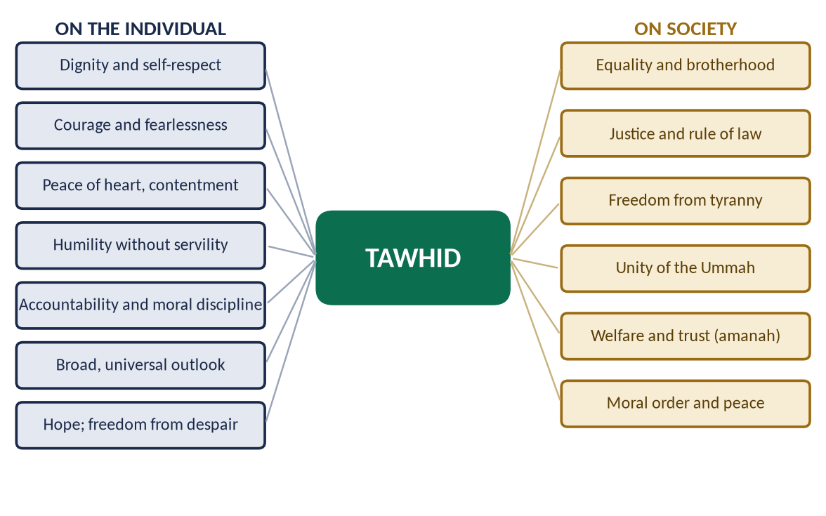
Figure 9 · The impact of Tauheed on the individual and on society.

(i) Equality and brotherhood
✦ QURAN
﴿يَـٰٓأَيُّهَا ٱلنَّاسُ ٱتَّقُواْ رَبَّكُمُ ٱلَّذِي خَلَقَكُم مِّن نَّفۡسٖ وَٰحِدَةٖ وَخَلَقَ مِنۡهَا زَوۡجَهَا وَبَثَّ مِنۡهُمَا رِجَالٗا كَثِيرٗا وَنِسَآءٗۚ وَٱتَّقُواْ ٱللَّهَ ٱلَّذِي تَسَآءَلُونَ بِهِۦ وَٱلۡأَرۡحَامَۚ إِنَّ ٱللَّهَ كَانَ عَلَيۡكُمۡ رَقِيبٗا﴾
“O mankind, fear your Lord, who created you from one soul and created from it its mate and dispersed from both of them many men and women. And fear Allah, through whom you ask one another, and the wombs. Indeed Allah is ever, over you, an Observer.” (An-Nisa, Quran)
➜ All mankind was created from one soul — one Lord, one origin, one family.

✦ SCHOLARLY VIEW
Allama Muhammad Iqbal · The Reconstruction of Religious Thought in Islam
“The essence of Tawhid as a working idea is equality, solidarity, and freedom.”
➜ Tauheed is a social principle.

(ii) Justice and the rule of law
✦ HADITH
وَايْمُ اللَّهِ لَوْ أَنَّ فَاطِمَةَ بِنْتَ مُحَمَّدٍ سَرَقَتْ لَقَطَعْتُ يَدَهَا
“By Allah, if Fatimah the daughter of Muhammad were to steal, I would cut off her hand.” (Al-Bukhari and Muslim)
➜ Under Tauheed no one is above the law.

(iii) Freedom from tyranny and exploitation
✦ QURAN
﴿قُلۡ يَـٰٓأَهۡلَ ٱلۡكِتَٰبِ تَعَالَوۡاْ إِلَىٰ كَلِمَةٖ سَوَآءِۭ بَيۡنَنَا وَبَيۡنَكُمۡ أَلَّا نَعۡبُدَ إِلَّا ٱللَّهَ وَلَا نُشۡرِكَ بِهِۦ شَيۡـٔٗا وَلَا يَتَّخِذَ بَعۡضُنَا بَعۡضًا أَرۡبَابٗا مِّن دُونِ ٱللَّهِۚ …﴾
“Say: O People of the Scripture, come to a word common between us and you: that we worship none but Allah, associate nothing with Him, and that none of us take others as lords besides Allah.” (Aal-e-Imran, Quran)
➜ '… that none of us take others as lords besides Allah' — no human being may claim absolute obedience.

- (a) Example: Rib'i ibn Amir (RA) told the Persian commander Rustam that Muslims had come to bring people 'from the worship of servants to the worship of the Lord of servants'.

(iv) Unity of the Ummah
✦ QURAN
﴿إِنَّ هَٰذِهِۦٓ أُمَّتُكُمۡ أُمَّةٗ وَٰحِدَةٗ وَأَنَا۠ رَبُّكُمۡ فَٱعۡبُدُونِ﴾
“Indeed this, your religion, is one religion, and I am your Lord, so worship Me.” (Al-Anbiya, Quran)
➜ 'This, your Ummah, is one Ummah, and I am your Lord.'

(v) Cooperation and welfare
✦ QURAN
﴿… وَتَعَاوَنُواْ عَلَى ٱلۡبِرِّ وَٱلتَّقۡوَىٰۖ وَلَا تَعَاوَنُواْ عَلَى ٱلۡإِثۡمِ وَٱلۡعُدۡوَٰنِۚ …﴾
“Cooperate in righteousness and piety, and do not cooperate in sin and aggression.” (Al-Ma'idah, Quran)
➜ Cooperate in righteousness and piety, not in sin and aggression.

(vi) Moral order and peace
A society that believes Allah sees every act needs fewer police and prisons; honesty and trust become social habits.

(7) Shirk and the modern idols
✦ QURAN
﴿وَإِذۡ قَالَ لُقۡمَٰنُ لِٱبۡنِهِۦ وَهُوَ يَعِظُهُۥ يَٰبُنَيَّ لَا تُشۡرِكۡ بِٱللَّهِۖ إِنَّ ٱلشِّرۡكَ لَظُلۡمٌ عَظِيمٞ﴾
“And [mention, O Muhammad], when Luqman said to his son while he was instructing him, "O my son, do not associate [anything] with Allah. Indeed, association [with him] is great injustice.” (Luqman, Quran)
➜ 'Shirk is a great injustice' — to Allah's right and to man's dignity.

Today's idols are wealth, power, the ego and desire; the Quran warns of the one who 'takes his desire as his god' (Al-Furqan). A materialist society that worships consumption is suffering from a modern form of shirk — and Tauheed is its cure.
PAKISTAN ANGLE
The Objectives Resolution (Article 2A) begins: 'Sovereignty over the entire Universe belongs to Allah Almighty alone' — Tauheed of sovereignty as the foundation of Pakistan's constitution.

(8) Conclusion
Tauheed is the root from which the whole tree of Islam grows. In the individual it produces dignity, courage, peace, accountability and hope; in society it produces equality, justice, freedom and unity. It is the charter of human liberation: one prostration to Allah that frees man from all others.
✦ HADITH
قُلْ آمَنْتُ بِاللَّهِ، ثُمَّ اسْتَقِمْ
“Say: 'I believe in Allah', and then stand firm.” (Muslim)
➜ Tauheed is belief followed by steadfast living — the whole answer in four words.

Why this answer scores
- The definition is complete (literal, technical, Kalimah, kinds).
- Eight individual and six social impacts, each with a heading and evidence — 'elaborate' is fulfilled.
- Two figures, Iqbal twice, and the constitutional link show depth and application.

Answer 5 · Rational Arguments for the Existence of Allah; the Impact of Monotheism (CSS 2026)
THE QUESTION · CSS 2026 · Q5 · 20 marks
What are the rational arguments for the existence of Allah? Explain the impacts of the belief in monotheism on human life.

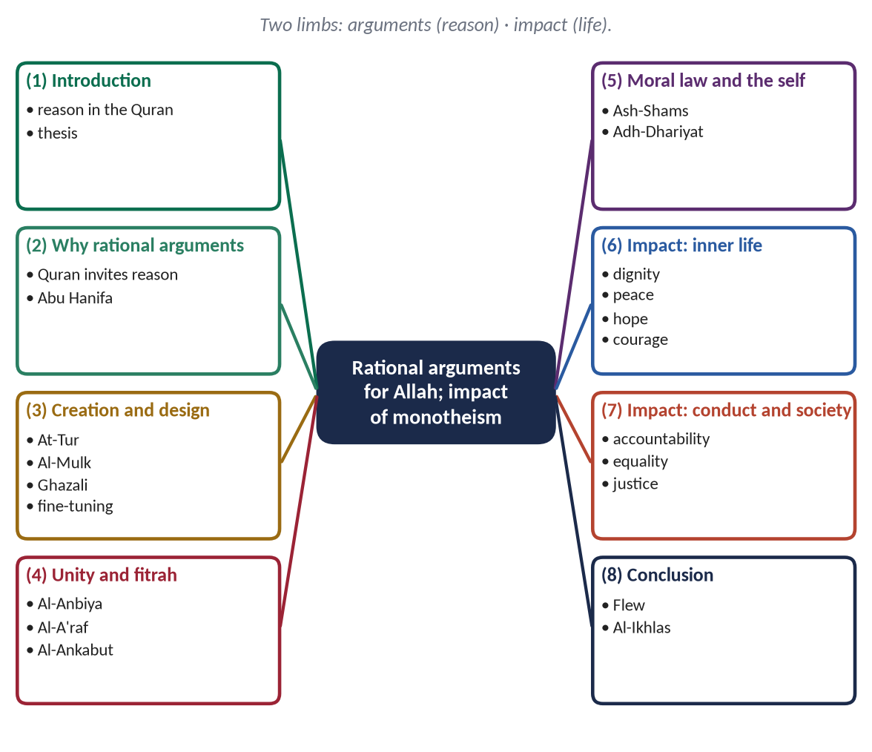
Figure 10 · The answer map: every branch is one numbered heading of the model answer below.

Decoding the question
- 'Rational arguments' — the examiner wants reason, not only scripture. Present each argument logically (premises → conclusion), then show that the Quran makes the same argument.
- 'Existence of Allah' — include the argument for oneness as well: the question later says 'monotheism'.
- 'Impacts … on human life' — broader than 'individual and society': cover the inner life, conduct and social life.

The model answer

(1) Introduction
✦ QURAN
﴿إِنَّ فِي خَلۡقِ ٱلسَّمَٰوَٰتِ وَٱلۡأَرۡضِ وَٱخۡتِلَٰفِ ٱلَّيۡلِ وَٱلنَّهَارِ لَأٓيَٰتٖ لِّأُوْلِي ٱلۡأَلۡبَٰبِ ۝ ٱلَّذِينَ يَذۡكُرُونَ ٱللَّهَ قِيَٰمٗا وَقُعُودٗا وَعَلَىٰ جُنُوبِهِمۡ وَيَتَفَكَّرُونَ فِي خَلۡقِ ٱلسَّمَٰوَٰتِ وَٱلۡأَرۡضِ رَبَّنَا مَا خَلَقۡتَ هَٰذَا بَٰطِلٗا سُبۡحَٰنَكَ فَقِنَا عَذَابَ ٱلنَّارِ﴾
“Indeed, in the creation of the heavens and the earth and the alternation of the night and the day are signs for those of understanding. Who remember Allah while standing or sitting or [lying] on their sides and give thought to the creation of the heavens and the earth, [saying], "Our Lord, You did not create this aimlessly; exalted are You [above such a thing]; then protect us from the punishment of the Fire.” (Aal-e-Imran, Quran)
➜ In the creation of the heavens and the earth and the alternation of night and day are signs for people of understanding, who remember Allah and reflect on the creation.

The Quran does not ask man to believe in God blindly. It invites him to look, think and reason — and it gives him arguments that philosophers still discuss. The question of God's existence is the most important question a human being can ask, because everything else — morality, purpose, hope — depends on the answer. This answer sets out the main rational arguments for the existence and oneness of Allah, and then explains how belief in monotheism transforms human life.

(2) Why rational arguments matter in Islam

(i) The Quran argues
The Quran repeatedly asks: 'Do you not reason?', 'Do you not reflect?', 'Do they not look?'

(ii) The scholars argued
✦ SCHOLARLY VIEW
Imam Abu Hanifa · a well-known story told of the Imam
Challenged by atheists, the Imam asked what they would say of a ship that loaded its cargo, crossed stormy seas and reached port with no captain. When they called it impossible, he replied that if a ship cannot run itself, the universe cannot run itself without a Creator.
➜ The founder of the Hanafi school used reason to defend faith.

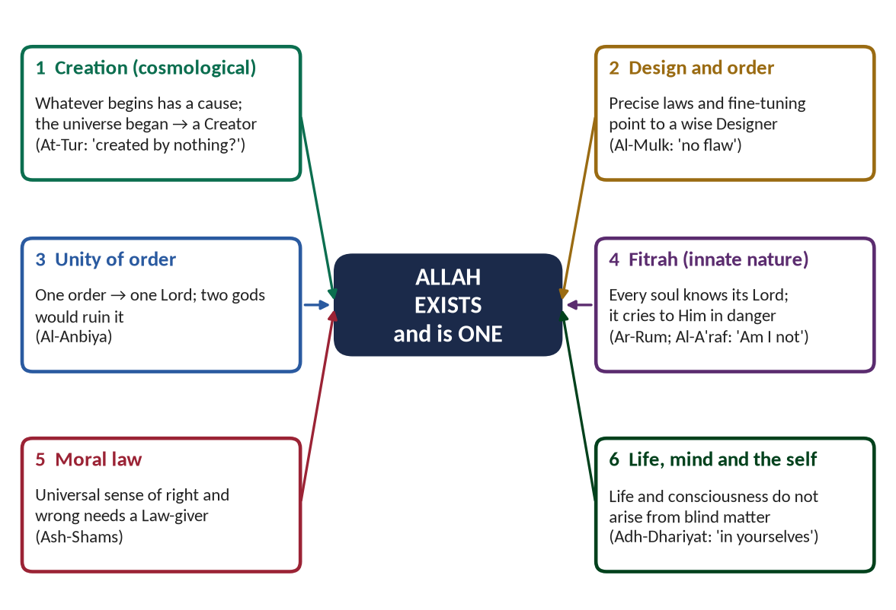
Figure 11 · The six rational arguments for the existence and oneness of Allah.

(3) The argument from creation (cosmological)

(i) The argument
Premise 1: Everything that begins to exist has a cause. Premise 2: The universe began to exist. Conclusion: The universe has a cause — an uncreated Creator.
✦ QURAN
﴿أَمۡ خُلِقُواْ مِنۡ غَيۡرِ شَيۡءٍ أَمۡ هُمُ ٱلۡخَٰلِقُونَ ۝ أَمۡ خَلَقُواْ ٱلسَّمَٰوَٰتِ وَٱلۡأَرۡضَۚ بَل لَّا يُوقِنُونَ﴾
“Or were they created by nothing, or were they the creators [of themselves]. Or did they create the heavens and the earth? Rather, they are not certain.” (At-Tur, Quran)
➜ Were they created by nothing, or were they the creators of themselves? Or did they create the heavens and the earth?

(ii) Its history and support
✦ SCHOLARLY VIEW
Imam Al-Ghazali · Al-Iqtisad fi al-I'tiqad
Ghazali set out the argument in its classic form — whatever comes into being has a cause; the world came into being; so it has a cause — and it is still known in Western philosophy as the 'Kalam cosmological argument'.
➜ A Muslim argument still taught in universities worldwide.

Modern cosmology agrees that the universe had a beginning; a universe with a beginning cannot be its own cause.

(4) The argument from design and fine-tuning (teleological)

(i) The argument
The universe shows precise order and fine-tuning: the constants of nature, the position of the earth, the balance of the atmosphere, the information coded in DNA. Order of this kind points to a wise Designer, not to chance.
✦ QURAN
﴿ٱلَّذِي خَلَقَ سَبۡعَ سَمَٰوَٰتٖ طِبَاقٗاۖ مَّا تَرَىٰ فِي خَلۡقِ ٱلرَّحۡمَٰنِ مِن تَفَٰوُتٖۖ فَٱرۡجِعِ ٱلۡبَصَرَ هَلۡ تَرَىٰ مِن فُطُورٖ ۝ ثُمَّ ٱرۡجِعِ ٱلۡبَصَرَ كَرَّتَيۡنِ يَنقَلِبۡ إِلَيۡكَ ٱلۡبَصَرُ خَاسِئٗا وَهُوَ حَسِيرٞ﴾
“[And] who created seven heavens in layers. You do not see in the creation of the Most Merciful any inconsistency. So return [your] vision [to the sky]; do you see any breaks. Then return [your] vision twice again. [Your] vision will return to you humbled while it is fatigued.” (Al-Mulk, Quran)
➜ You do not see any flaw in the creation of the Most Merciful. Look again: do you see any rift?

✦ QURAN
﴿ٱلَّذِي لَهُۥ مُلۡكُ ٱلسَّمَٰوَٰتِ وَٱلۡأَرۡضِ وَلَمۡ يَتَّخِذۡ وَلَدٗا وَلَمۡ يَكُن لَّهُۥ شَرِيكٞ فِي ٱلۡمُلۡكِ وَخَلَقَ كُلَّ شَيۡءٖ فَقَدَّرَهُۥ تَقۡدِيرٗا﴾
“He to whom belongs the dominion of the heavens and the earth and who has not taken a son and has not had a partner in dominion and has created each thing and determined it with [precise] determination.” (Al-Furqan, Quran)
➜ He created everything and determined it with precise measure.

(ii) A modern witness
The British philosopher Antony Flew, a leading atheist for fifty years, announced in 2004 that the complexity of DNA and the fine-tuning of the universe had led him to accept an intelligent Creator (There Is a God, 2007).

(5) The argument from the unity of order — for one God
One consistent law runs through the whole universe. One order implies one Lord: two independent gods would mean two wills and chaos.
✦ QURAN
﴿لَوۡ كَانَ فِيهِمَآ ءَالِهَةٌ إِلَّا ٱللَّهُ لَفَسَدَتَاۚ فَسُبۡحَٰنَ ٱللَّهِ رَبِّ ٱلۡعَرۡشِ عَمَّا يَصِفُونَ﴾
“Had there been within the heavens and earth gods besides Allah, they both would have been ruined. So exalted is Allah, Lord of the Throne, above what they describe.” (Al-Anbiya, Quran)
➜ Had there been gods besides Allah in the heavens and earth, both would have been ruined.

(6) The argument from the fitrah
Belief in a Creator is found in every culture and rises to the surface in danger, even in those who deny Him.
✦ QURAN
﴿وَإِذۡ أَخَذَ رَبُّكَ مِنۢ بَنِيٓ ءَادَمَ مِن ظُهُورِهِمۡ ذُرِّيَّتَهُمۡ وَأَشۡهَدَهُمۡ عَلَىٰٓ أَنفُسِهِمۡ أَلَسۡتُ بِرَبِّكُمۡۖ قَالُواْ بَلَىٰ شَهِدۡنَآۚ أَن تَقُولُواْ يَوۡمَ ٱلۡقِيَٰمَةِ إِنَّا كُنَّا عَنۡ هَٰذَا غَٰفِلِينَ﴾
“And [mention] when your Lord took from the children of Adam - from their loins - their descendants and made them testify of themselves, [saying to them], "Am I not your Lord?" They said, "Yes, we have testified." [This] - lest you should say on the day of Resurrection, "Indeed, we were of this unaware.” (Al-A'raf, Quran)
➜ The covenant of the souls: 'Am I not your Lord?' They said: 'Yes.'

✦ QURAN
﴿فَإِذَا رَكِبُواْ فِي ٱلۡفُلۡكِ دَعَوُاْ ٱللَّهَ مُخۡلِصِينَ لَهُ ٱلدِّينَ فَلَمَّا نَجَّىٰهُمۡ إِلَى ٱلۡبَرِّ إِذَا هُمۡ يُشۡرِكُونَ﴾
“And when they board a ship, they supplicate Allah, sincere to Him in religion. But when He delivers them to the land, at once they associate others with Him.” (Al-Ankabut, Quran)
➜ In a storm at sea, they call upon Allah sincerely — the fitrah speaks.

(7) The moral argument and the argument from the self

(i) Objective morality needs a Law-giver
All people know that some acts — torturing the innocent — are truly evil. If morality were only custom or evolution, nothing would be truly evil. Objective moral law points to a Moral Law-giver.
✦ QURAN
﴿وَنَفۡسٖ وَمَا سَوَّىٰهَا ۝ فَأَلۡهَمَهَا فُجُورَهَا وَتَقۡوَىٰهَا﴾
“And [by] the soul and He who proportioned it. And inspired it [with discernment of] its wickedness and its righteousness.” (Ash-Shams, Quran)
➜ By the soul and Him who proportioned it, and inspired it with its wickedness and its righteousness.

(ii) Life and consciousness
Thought, love and conscience cannot be explained as products of blind matter.
✦ QURAN
﴿وَفِي ٱلۡأَرۡضِ ءَايَٰتٞ لِّلۡمُوقِنِينَ ۝ وَفِيٓ أَنفُسِكُمۡۚ أَفَلَا تُبۡصِرُونَ﴾
“And on the earth are signs for the certain [in faith]. And in yourselves. Then will you not see.” (Adh-Dhariyat, Quran)
➜ On the earth are signs, and in yourselves — do you not see?

(8) The impact of belief in monotheism on human life

(i) On the inner life
- (a) Dignity: the believer bows to no creature (Iqbal: 'one prostration frees from a thousand').
- (b) Peace: 'in the remembrance of Allah hearts find rest' (Ar-Ra'd).
- (c) Hope: 'do not despair of the mercy of Allah' (Az-Zumar).
- (d) Courage: 'Allah is sufficient for us' (Aal-e-Imran).

(ii) On conduct
- (a) Accountability: 'He is with you wherever you are' (Al-Hadid).
- (b) Sincerity: actions done for Allah, not for show — riya is 'minor shirk' (Musnad Ahmad).
- (c) Balance: effort with trust — 'tie your camel, then trust' (Al-Tirmidhi).

(iii) On society
- (a) Equality: 'the most honoured of you is the most righteous' (Al-Hujurat).
- (b) Justice: no one above the law — the Fatimah hadith (Al-Bukhari and Muslim).
- (c) Freedom: 'none of us take others as lords besides Allah' (Aal-e-Imran).
- (d) Unity: 'this, your Ummah, is one Ummah' (Al-Anbiya).
✦ SCHOLARLY VIEW
Allama Muhammad Iqbal · The Reconstruction of Religious Thought in Islam
“The essence of Tawhid as a working idea is equality, solidarity, and freedom.”
➜ Monotheism's impact on human life in one line.

HOT DEBATE · THE 'PROBLEM OF EVIL'
A modern examiner may expect you to address the commonest objection: why does a good God allow suffering? Answer briefly: life is a test (Al-Mulk); much suffering is man-made through free will (Ar-Rum: 'corruption has appeared … because of what men's hands have earned'); and the Hereafter completes justice.

(9) Conclusion
Reason, rightly used, leads to Allah: a universe that began needs a Creator; a universe of precise order needs a Designer; a single law needs a single Lawgiver; the fitrah, the conscience and the mind all point beyond matter. Belief in this One God then remakes human life — giving it dignity, peace, accountability, equality and freedom. The Quran's summary remains the best:
✦ QURAN
﴿قُلۡ هُوَ ٱللَّهُ أَحَدٌ ۝ ٱللَّهُ ٱلصَّمَدُ ۝ لَمۡ يَلِدۡ وَلَمۡ يُولَدۡ ۝ وَلَمۡ يَكُن لَّهُۥ كُفُوًا أَحَدُۢ﴾
“Say, "He is Allah, [who is] One. Allah, the Eternal Refuge. He neither begets nor is born. Nor is there to Him any equivalent.” (Al-Ikhlas, Quran)
➜ 'Say: He is Allah, the One …' — the conclusion of reason and the beginning of faith.

Why this answer scores
- Each argument is stated rationally (premise → conclusion) and then matched with the Quran — exactly what 'rational arguments' demands.
- It includes oneness, anticipating 'monotheism' in the second limb.
- Modern witnesses (Flew, cosmology) and a classical one (Ghazali, Abu Hanifa) balance the answer; the problem of evil is answered briefly.

Answer 6 · The Doctrine of Prophethood and Its Importance in Human Life (CSS 2022 and 2024)
THE QUESTION · CSS 2022 · Q5 and CSS 2024 · Q4 (repeated word for word) · 20 marks
Explain the doctrine of Prophethood and its importance in human life.

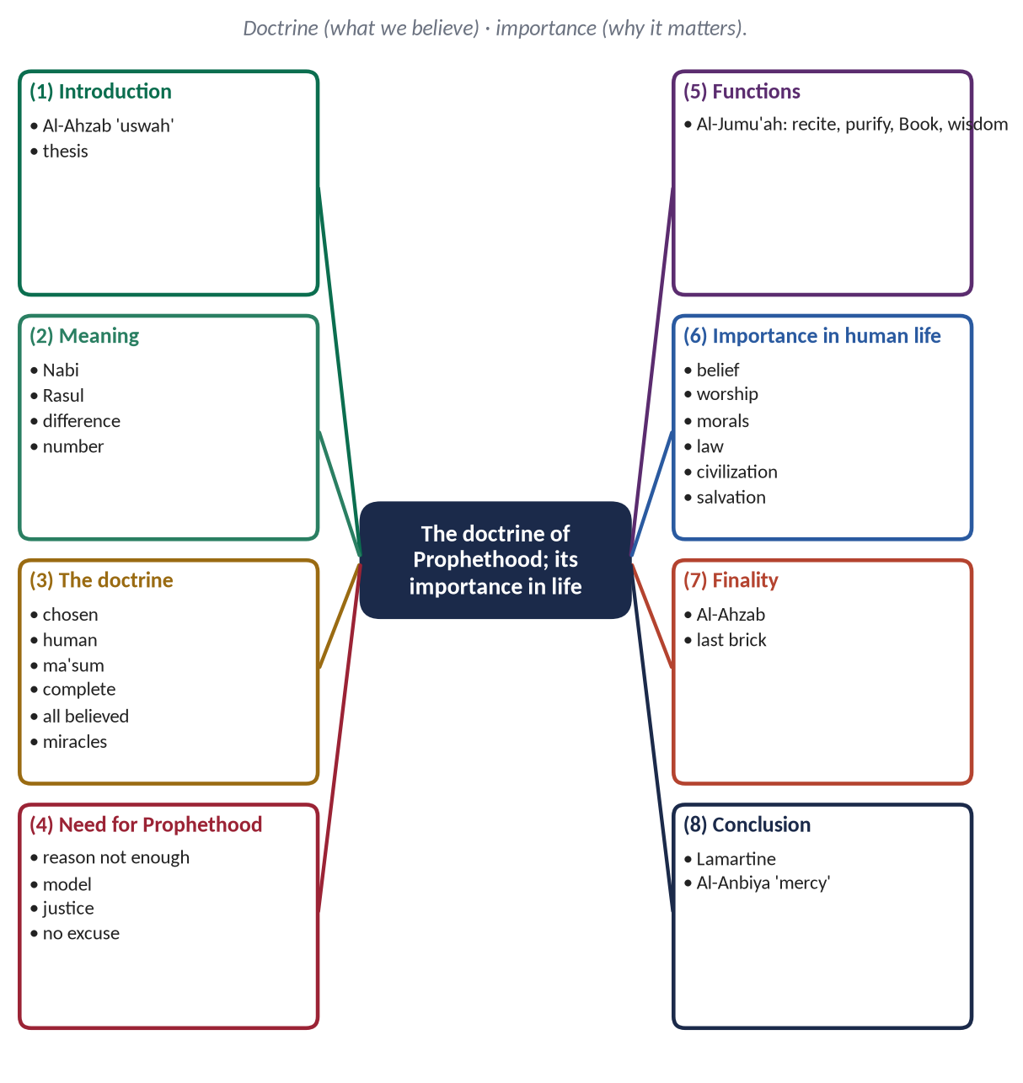
Figure 12 · The answer map: every branch is one numbered heading of the model answer below.

Decoding the question
- 'Explain the doctrine' — what a Muslim believes about Prophethood: its meaning, the nature of Prophets, their functions and qualities, and the finality.
- 'Its importance in human life' — why humanity needs Prophethood: in belief, worship, morality, law, society, civilization and the Hereafter.
- Asked twice in three years — a certain favourite. Give both limbs full weight.

The model answer

(1) Introduction
✦ QURAN
﴿لَّقَدۡ كَانَ لَكُمۡ فِي رَسُولِ ٱللَّهِ أُسۡوَةٌ حَسَنَةٞ لِّمَن كَانَ يَرۡجُواْ ٱللَّهَ وَٱلۡيَوۡمَ ٱلۡأٓخِرَ وَذَكَرَ ٱللَّهَ كَثِيرٗا﴾
“There has certainly been for you in the Messenger of Allah an excellent pattern for anyone whose hope is in Allah and the Last Day and [who] remembers Allah often.” (Al-Ahzab, Quran)
➜ 'There has certainly been for you in the Messenger of Allah an excellent pattern for anyone whose hope is in Allah and the Last Day.'

Allah did not leave mankind to find its way by guesswork. From Adam to Muhammad ﷺ, He chose human beings to receive His guidance, live it and teach it. This is Risalat — Prophethood — the second article of faith after Tawhid. Without it, we would know that God exists but not what He wants; we would have values without a model and laws without authority. This answer explains the Islamic doctrine of Prophethood and then shows its importance in every department of human life.

(2) The meaning of Nubuwwah and Risalah

(i) Nabi
From naba' ('great news'): one who receives and conveys news from Allah.

(ii) Rasul
From irsal ('sending'): one sent with a message, usually a new Shariah or Book.

(iii) The difference and the number
Every Rasul is a Nabi, but not every Nabi is a Rasul. Twenty-five Prophets are named in the Quran; a narration in Musnad Ahmad speaks of about 124,000.
✦ QURAN
﴿إِنَّآ أَرۡسَلۡنَٰكَ بِٱلۡحَقِّ بَشِيرٗا وَنَذِيرٗاۚ وَإِن مِّنۡ أُمَّةٍ إِلَّا خَلَا فِيهَا نَذِيرٞ﴾
“Indeed, We have sent you with the truth as a bringer of good tidings and a warner. And there was no nation but that there had passed within it a warner.” (Fatir, Quran)
➜ There was no nation but that a warner had passed among them.

(3) The doctrine: what a Muslim believes about the Prophets

(i) Prophethood is chosen by Allah, not earned
✦ QURAN
﴿… ٱللَّهُ أَعۡلَمُ حَيۡثُ يَجۡعَلُ رِسَالَتَهُۥۗ …﴾
“Allah knows best where to place His message.” (Al-An'am, Quran)
➜ 'Allah knows best where to place His message.'

(ii) The Prophets are human beings
✦ QURAN
﴿قُلۡ إِنَّمَآ أَنَا۠ بَشَرٞ مِّثۡلُكُمۡ يُوحَىٰٓ إِلَيَّ أَنَّمَآ إِلَٰهُكُمۡ إِلَٰهٞ وَٰحِدٞۖ فَمَن كَانَ يَرۡجُواْ لِقَآءَ رَبِّهِۦ فَلۡيَعۡمَلۡ عَمَلٗا صَٰلِحٗا وَلَا يُشۡرِكۡ بِعِبَادَةِ رَبِّهِۦٓ أَحَدَۢا﴾
“Say, "I am only a man like you, to whom has been revealed that your god is one God. So whoever would hope for the meeting with his Lord - let him do righteous work and not associate in the worship of his Lord anyone.” (Al-Kahf, Quran)
➜ 'Say: I am only a man like you, to whom it has been revealed that your God is one God.'

(iii) The Prophets are protected from sin (ismah)
So that their example can be followed without fear of error.

(iv) They convey the message completely
✦ QURAN
﴿يَـٰٓأَيُّهَا ٱلرَّسُولُ بَلِّغۡ مَآ أُنزِلَ إِلَيۡكَ مِن رَّبِّكَۖ وَإِن لَّمۡ تَفۡعَلۡ فَمَا بَلَّغۡتَ رِسَالَتَهُۥۚ وَٱللَّهُ يَعۡصِمُكَ مِنَ ٱلنَّاسِۗ إِنَّ ٱللَّهَ لَا يَهۡدِي ٱلۡقَوۡمَ ٱلۡكَٰفِرِينَ﴾
“O Messenger, announce that which has been revealed to you from your Lord, and if you do not, then you have not conveyed His message. And Allah will protect you from the people. Indeed, Allah does not guide the disbelieving people.” (Al-Ma'idah, Quran)
➜ 'O Messenger, convey what has been revealed to you.'

(v) Belief in all of them is required
✦ QURAN
﴿ءَامَنَ ٱلرَّسُولُ بِمَآ أُنزِلَ إِلَيۡهِ مِن رَّبِّهِۦ وَٱلۡمُؤۡمِنُونَۚ كُلٌّ ءَامَنَ بِٱللَّهِ وَمَلَـٰٓئِكَتِهِۦ وَكُتُبِهِۦ وَرُسُلِهِۦ لَا نُفَرِّقُ بَيۡنَ أَحَدٖ مِّن رُّسُلِهِۦۚ وَقَالُواْ سَمِعۡنَا وَأَطَعۡنَاۖ غُفۡرَانَكَ رَبَّنَا وَإِلَيۡكَ ٱلۡمَصِيرُ﴾
“The Messenger has believed in what was revealed to him from his Lord, and [so have] the believers. All of them have believed in Allah and His angels and His books and His messengers, [saying], "We make no distinction between any of His messengers." And they say, "We hear and we obey. [We seek] Your forgiveness, our Lord, and to You is the [final] destination.” (Al-Baqarah, Quran)
➜ 'We make no distinction between any of His messengers.'

(vi) They are supported by miracles
The staff of Musa (AS), the healing of Isa (AS) — and the Quran, the lasting miracle of the last Prophet ﷺ.

(vii) Their qualities
Sidq (truthfulness), amanah (trustworthiness), tabligh (conveying), fatanah (wisdom). The Prophet ﷺ was called al-Sadiq al-Amin by his opponents.

(4) The need for Prophethood
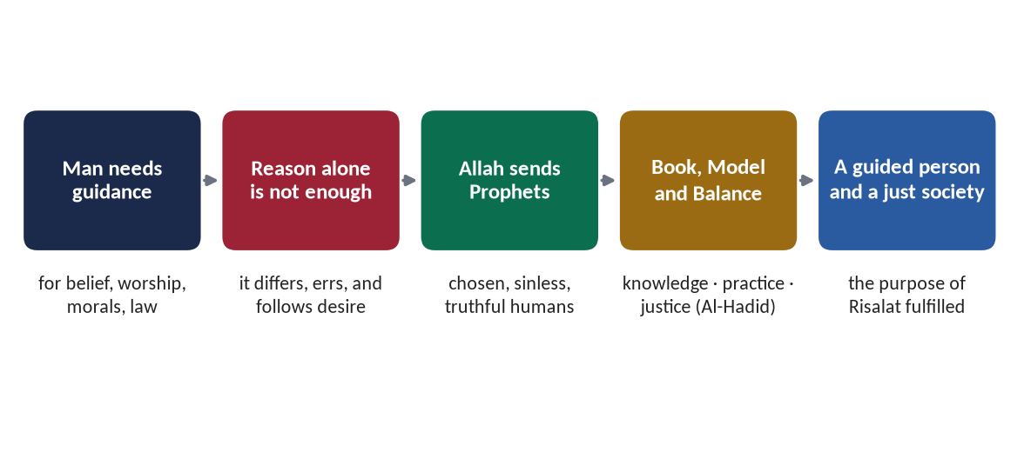
Figure 13 · Why mankind needs Prophets.

(i) Reason cannot find Allah's will
Reason may reach the existence of God, but not how He is to be worshipped or what He has made lawful.

(ii) Man needs a living model
✦ SCHOLARLY VIEW
Syed Sulaiman Nadvi · Khutbat-e-Madras (1925)
Nadvi argues that a universal model must be historical, comprehensive, complete and practical — and that only the life of the Prophet Muhammad ﷺ meets all four conditions.
➜ Why guidance needed a human model, not only a book.

(iii) Justice needs a revealed standard
✦ QURAN
﴿لَقَدۡ أَرۡسَلۡنَا رُسُلَنَا بِٱلۡبَيِّنَٰتِ وَأَنزَلۡنَا مَعَهُمُ ٱلۡكِتَٰبَ وَٱلۡمِيزَانَ لِيَقُومَ ٱلنَّاسُ بِٱلۡقِسۡطِۖ وَأَنزَلۡنَا ٱلۡحَدِيدَ فِيهِ بَأۡسٞ شَدِيدٞ وَمَنَٰفِعُ لِلنَّاسِ وَلِيَعۡلَمَ ٱللَّهُ مَن يَنصُرُهُۥ وَرُسُلَهُۥ بِٱلۡغَيۡبِۚ إِنَّ ٱللَّهَ قَوِيٌّ عَزِيزٞ﴾
“We have already sent Our messengers with clear evidences and sent down with them the Scripture and the balance that the people may maintain [their affairs] in justice. And We sent down iron, wherein is great military might and benefits for the people, and so that Allah may make evident those who support Him and His messengers unseen. Indeed, Allah is Powerful and Exalted in Might.” (Al-Hadid, Quran)
➜ Messengers were sent with the Book and the Balance so that people may uphold justice.

(iv) No one may plead ignorance
✦ QURAN
﴿رُّسُلٗا مُّبَشِّرِينَ وَمُنذِرِينَ لِئَلَّا يَكُونَ لِلنَّاسِ عَلَى ٱللَّهِ حُجَّةُۢ بَعۡدَ ٱلرُّسُلِۚ وَكَانَ ٱللَّهُ عَزِيزًا حَكِيمٗا﴾
“[We sent] messengers as bringers of good tidings and warners so that mankind will have no argument against Allah after the messengers. And ever is Allah Exalted in Might and Wise.” (An-Nisa, Quran)
➜ Messengers were sent so that mankind will have no argument against Allah.

(5) The functions of the Prophets
✦ QURAN
﴿هُوَ ٱلَّذِي بَعَثَ فِي ٱلۡأُمِّيِّـۧنَ رَسُولٗا مِّنۡهُمۡ يَتۡلُواْ عَلَيۡهِمۡ ءَايَٰتِهِۦ وَيُزَكِّيهِمۡ وَيُعَلِّمُهُمُ ٱلۡكِتَٰبَ وَٱلۡحِكۡمَةَ وَإِن كَانُواْ مِن قَبۡلُ لَفِي ضَلَٰلٖ مُّبِينٖ﴾
“It is He who has sent among the unlettered a Messenger from themselves reciting to them His verses and purifying them and teaching them the Book and wisdom - although they were before in clear error.” (Al-Jumu'ah, Quran)
➜ He sent a Messenger reciting His verses, purifying them, and teaching them the Book and wisdom.

- (a) Tilawah: conveying the revelation exactly.
- (b) Tazkiyah: purifying hearts and habits.
- (c) Ta'lim al-Kitab: teaching the meaning and law of the Book.
- (d) Hikmah: showing how to apply it — the Sunnah.

(6) The importance of Prophethood in human life

(i) In belief — the door to the knowledge of Allah
All that we know of Allah's names, His angels, His Books and the Hereafter reaches us only through the Prophets.

(ii) In worship — the method
✦ HADITH
صَلُّوا كَمَا رَأَيْتُمُونِي أُصَلِّي
“Pray as you have seen me praying.” (Al-Bukhari)
➜ Worship is learned from the Prophet; without him no one would know how to pray.

(iii) In morality — the standard
✦ QURAN
﴿وَإِنَّكَ لَعَلَىٰ خُلُقٍ عَظِيمٖ﴾
“And indeed, you are of a great moral character.” (Al-Qalam, Quran)
➜ 'You are truly of an exalted character.'

✦ HADITH
لَا يُؤْمِنُ أَحَدُكُمْ حَتَّى أَكُونَ أَحَبَّ إِلَيْهِ مِنْ وَالِدِهِ وَوَلَدِهِ وَالنَّاسِ أَجْمَعِينَ
“None of you truly believes until I am more beloved to him than his father, his child and all people.” (Al-Bukhari and Muslim)
➜ Love of the Prophet ﷺ turns his example into the motive of a believer's conduct.

(iv) In law and society — the authority
✦ QURAN
﴿مَّن يُطِعِ ٱلرَّسُولَ فَقَدۡ أَطَاعَ ٱللَّهَۖ وَمَن تَوَلَّىٰ فَمَآ أَرۡسَلۡنَٰكَ عَلَيۡهِمۡ حَفِيظٗا﴾
“He who obeys the Messenger has obeyed Allah; but those who turn away - We have not sent you over them as a guardian.” (An-Nisa, Quran)
➜ 'Whoever obeys the Messenger has obeyed Allah.'

✦ QURAN
﴿فَلَا وَرَبِّكَ لَا يُؤۡمِنُونَ حَتَّىٰ يُحَكِّمُوكَ فِيمَا شَجَرَ بَيۡنَهُمۡ ثُمَّ لَا يَجِدُواْ فِيٓ أَنفُسِهِمۡ حَرَجٗا مِّمَّا قَضَيۡتَ وَيُسَلِّمُواْ تَسۡلِيمٗا﴾
“But no, by your Lord, they will not [truly] believe until they make you, [O Muhammad], judge concerning that over which they dispute among themselves and then find within themselves no discomfort from what you have judged and submit in [full, willing] submission.” (An-Nisa, Quran)
➜ They do not truly believe until they make you judge in their disputes.

(v) In civilization — the founders of just societies
Every moral civilization began with a Prophet. In ten years, the Prophet ﷺ founded in Madinah a state with a written charter, courts, a treasury for the poor and a brotherhood across tribes.
✦ SCHOLARLY VIEW
Alphonse de Lamartine · Histoire de la Turquie (1854)
“If greatness of purpose, smallness of means, and astonishing results are the three criteria of human genius, who could dare to compare any great man in modern history with Muhammad?”
➜ A European historian on the civilizational impact of Prophethood.

(vi) In the unity of mankind
All the Prophets taught one Din; a Muslim's belief in all of them builds respect for the whole history of faith.

(vii) In salvation
✦ QURAN
﴿وَمَن يُطِعِ ٱللَّهَ وَٱلرَّسُولَ فَأُوْلَـٰٓئِكَ مَعَ ٱلَّذِينَ أَنۡعَمَ ٱللَّهُ عَلَيۡهِم مِّنَ ٱلنَّبِيِّـۧنَ وَٱلصِّدِّيقِينَ وَٱلشُّهَدَآءِ وَٱلصَّـٰلِحِينَۚ وَحَسُنَ أُوْلَـٰٓئِكَ رَفِيقٗا﴾
“And whoever obeys Allah and the Messenger - those will be with the ones upon whom Allah has bestowed favor of the prophets, the steadfast affirmers of truth, the martyrs and the righteous. And excellent are those as companions.” (An-Nisa, Quran)
➜ Whoever obeys Allah and the Messenger will be with the Prophets, the truthful, the martyrs and the righteous.

(7) The completion of the doctrine: the Finality of Prophethood
✦ QURAN
﴿مَّا كَانَ مُحَمَّدٌ أَبَآ أَحَدٖ مِّن رِّجَالِكُمۡ وَلَٰكِن رَّسُولَ ٱللَّهِ وَخَاتَمَ ٱلنَّبِيِّـۧنَۗ وَكَانَ ٱللَّهُ بِكُلِّ شَيۡءٍ عَلِيمٗا﴾
“Muhammad is not the father of [any] one of your men, but [he is] the Messenger of Allah and last of the prophets. And ever is Allah, of all things, Knowing.” (Al-Ahzab, Quran)
➜ Muhammad ﷺ is the Messenger of Allah and the Seal of the Prophets.

✦ HADITH
فَأَنَا اللَّبِنَةُ، وَأَنَا خَاتِمُ النَّبِيِّينَ
“I am that [last] brick, and I am the seal of the Prophets.” (Al-Bukhari)
➜ The building of Prophethood is complete; its guidance now continues through the Quran, the Sunnah and the scholars.

PAKISTAN ANGLE
The Constitution protects the doctrine: Article 260(3) defines a Muslim as one who believes in the absolute and unqualified finality of the Prophethood of Muhammad ﷺ.

(8) Conclusion
Prophethood is Allah's answer to man's deepest need: to know his Lord's will and to see it lived. The Prophets are chosen, human, truthful and protected; they recite, purify, teach and model; and through them belief becomes worship, morality becomes law, and a people becomes a civilization. With the last Prophet ﷺ the doctrine was completed, and his life remains the model for all mankind.
✦ QURAN
﴿وَمَآ أَرۡسَلۡنَٰكَ إِلَّا رَحۡمَةٗ لِّلۡعَٰلَمِينَ﴾
“And We have not sent you, [O Muhammad], except as a mercy to the worlds.” (Al-Anbiya, Quran)
➜ 'We have not sent you except as a mercy to all the worlds.'

Why this answer scores
- 'Doctrine' is explained as a set of beliefs (seven points) — not a biography.
- 'Importance' is organised by the departments of human life, each proved.
- The finality section closes the doctrine and anticipates a twist; Nadvi and Lamartine give scholarly and external weight.

Answer 7 · Faith in Prophethood Requires Faith in Its Finality (CSS 2015)
THE QUESTION · CSS 2015 · Q4 · 16 marks (old scheme)
The entire faith in Prophethood is unacceptable without faith in finality of the Prophethood. Discuss in the light of Quran & Sunnah.

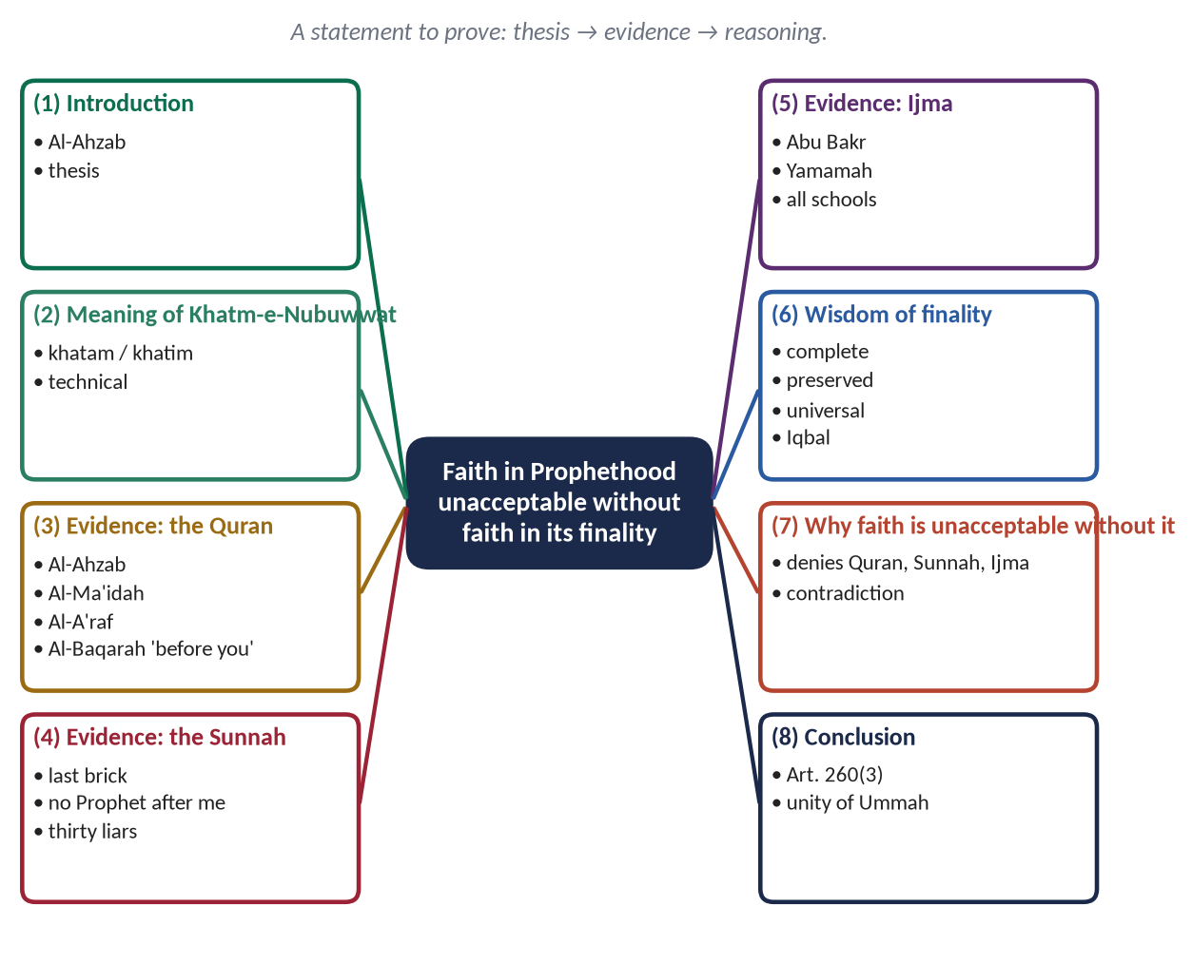
Figure 14 · The answer map: every branch is one numbered heading of the model answer below.

Decoding the question
- A statement to be discussed: agree with it and prove it.
- 'In the light of Quran & Sunnah' — the verses and ahadith are the core; add Ijma and rational wisdom as support.
- The heart of the answer is the logical link: why is faith in Prophethood itself unacceptable without faith in finality? Give this its own section.

The model answer

(1) Introduction
✦ QURAN
﴿مَّا كَانَ مُحَمَّدٌ أَبَآ أَحَدٖ مِّن رِّجَالِكُمۡ وَلَٰكِن رَّسُولَ ٱللَّهِ وَخَاتَمَ ٱلنَّبِيِّـۧنَۗ وَكَانَ ٱللَّهُ بِكُلِّ شَيۡءٍ عَلِيمٗا﴾
“Muhammad is not the father of [any] one of your men, but [he is] the Messenger of Allah and last of the prophets. And ever is Allah, of all things, Knowing.” (Al-Ahzab, Quran)
➜ 'Muhammad is not the father of any of your men, but he is the Messenger of Allah and the Seal of the Prophets; and Allah has full knowledge of all things.'

Belief in the Prophethood of Muhammad ﷺ is not a belief in a Prophet among many possible Prophets; it is belief in the last Prophet, through whom Allah completed His Din. The Quran calls him the Seal of the Prophets, he himself declared that there is no Prophet after him, and the Ummah has agreed on this for fourteen centuries. This answer shows that to accept him as a Prophet while denying his finality is self-contradictory — it rejects the very Quran and Sunnah on which his Prophethood rests.

(2) The meaning of Khatm-e-Nubuwwat

(i) Literal meaning
Khatam is a seal — what closes a document; khatim is the one who ends. Both readings of Al-Ahzab mean the last.

(ii) Technical meaning
The belief that Muhammad ﷺ is the last Prophet and Messenger; no Prophet of any kind will come after him until the Day of Judgement.

(3) The evidence of the Quran

(i) The explicit text
Al-Ahzab names him Khatam an-Nabiyyin — the Seal of the Prophets.

(ii) The completion of the Din
✦ QURAN
﴿… ٱلۡيَوۡمَ أَكۡمَلۡتُ لَكُمۡ دِينَكُمۡ وَأَتۡمَمۡتُ عَلَيۡكُمۡ نِعۡمَتِي وَرَضِيتُ لَكُمُ ٱلۡإِسۡلَٰمَ دِينٗاۚ …﴾
“This day I have perfected for you your religion, completed My favour upon you, and approved for you Islam as your way of life.” (Al-Ma'idah, Quran)
➜ A perfected Din needs no further Prophet.

(iii) A Prophet for all mankind
✦ QURAN
﴿قُلۡ يَـٰٓأَيُّهَا ٱلنَّاسُ إِنِّي رَسُولُ ٱللَّهِ إِلَيۡكُمۡ جَمِيعًا …﴾
“Say: O mankind, I am the Messenger of Allah to you all.” (Al-A'raf, Quran)
➜ 'Say: O mankind, I am the Messenger of Allah to you all.'

(iv) Revelation 'before you', never 'after you'
✦ QURAN
﴿وَٱلَّذِينَ يُؤۡمِنُونَ بِمَآ أُنزِلَ إِلَيۡكَ وَمَآ أُنزِلَ مِن قَبۡلِكَ وَبِٱلۡأٓخِرَةِ هُمۡ يُوقِنُونَ﴾
“And who believe in what has been revealed to you, [O Muhammad], and what was revealed before you, and of the Hereafter they are certain [in faith].” (Al-Baqarah, Quran)
➜ The believers believe in what was revealed to you and what was revealed before you — the Quran never mentions revelation after him.

(v) The preservation of the message
✦ QURAN
﴿إِنَّا نَحۡنُ نَزَّلۡنَا ٱلذِّكۡرَ وَإِنَّا لَهُۥ لَحَٰفِظُونَ﴾
“Indeed, it is We who sent down the Qur'an and indeed, We will be its guardian.” (Al-Hijr, Quran)
➜ 'We have sent down the Reminder, and We will surely guard it.'

(4) The evidence of the Sunnah

(i) The last brick
✦ HADITH
إِنَّ مَثَلِي وَمَثَلَ الْأَنْبِيَاءِ مِنْ قَبْلِي كَمَثَلِ رَجُلٍ بَنَى بَيْتًا فَأَحْسَنَهُ وَأَجْمَلَهُ إِلَّا مَوْضِعَ لَبِنَةٍ مِنْ زَاوِيَةٍ، فَجَعَلَ النَّاسُ يَطُوفُونَ بِهِ وَيَعْجَبُونَ لَهُ وَيَقُولُونَ: هَلَّا وُضِعَتْ هَذِهِ اللَّبِنَةُ؟ قَالَ: فَأَنَا اللَّبِنَةُ، وَأَنَا خَاتِمُ النَّبِيِّينَ
“My example and that of the Prophets before me is that of a man who built a fine and beautiful house except for the place of one brick in a corner; people walked around it, admired it and said, 'If only this brick were put in place!' I am that brick, and I am the seal of the Prophets.” (Al-Bukhari)
➜ The house of Prophethood is complete.

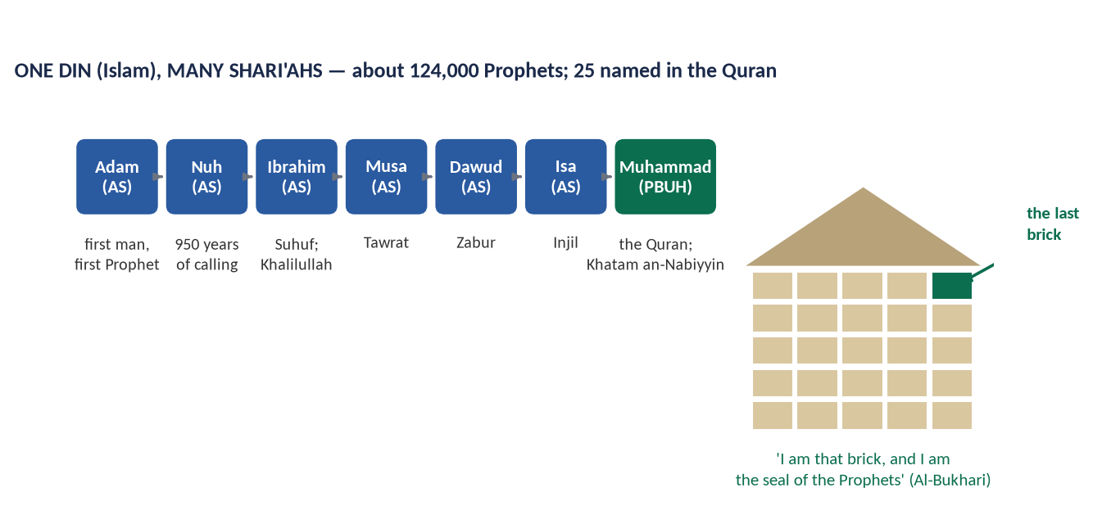
Figure 15 · The chain of Prophets and the parable of the last brick.

(ii) 'No Prophet after me'
✦ HADITH
أَمَا تَرْضَى أَنْ تَكُونَ مِنِّي بِمَنْزِلَةِ هَارُونَ مِنْ مُوسَى، إِلَّا أَنَّهُ لَا نَبِيَّ بَعْدِي
“Are you not pleased to be to me as Harun was to Musa — except that there is no Prophet after me?” (Al-Bukhari and Muslim)
➜ Not even Hazrat Ali (RA) could share Prophethood.

(iii) The thirty liars
✦ HADITH
وَإِنَّهُ سَيَكُونُ فِي أُمَّتِي كَذَّابُونَ ثَلَاثُونَ، كُلُّهُمْ يَزْعُمُ أَنَّهُ نَبِيٌّ، وَأَنَا خَاتَمُ النَّبِيِّينَ لَا نَبِيَّ بَعْدِي
“There will be in my Ummah thirty liars, each claiming to be a Prophet; and I am the seal of the Prophets — there is no Prophet after me.” (Abu Dawud and Al-Tirmidhi)
➜ Every later claim was condemned in advance.

(iv) Prophethood of every kind has ended
✦ HADITH
إِنَّ الرِّسَالَةَ وَالنُّبُوَّةَ قَدِ انْقَطَعَتْ، فَلَا رَسُولَ بَعْدِي وَلَا نَبِيَّ
“Messengership and Prophethood have ended: there is no Messenger after me and no Prophet.” (Al-Tirmidhi)
➜ No 'Nabi' of any type remains possible.

(5) The consensus (Ijma) of the Ummah

(i) The Companions
When Musaylimah, Aswad al-Ansi and Tulayhah claimed Prophethood, the Companions under Hazrat Abu Bakr (RA) unanimously rejected them; Musaylimah was defeated at Yamamah (11–12 AH).

(ii) Every school across fourteen centuries
All recognised schools of Muslim thought agree that belief in finality is an essential of faith.

(6) The wisdom of finality
- (a) The Din is complete — nothing remains to be revealed.
- (b) The message is preserved — the Quran word for word, the Sunnah by the isnad.
- (c) The message is universal — for all people and all time.
- (d) Humanity has come of age — guidance continues through reason under revelation.
✦ SCHOLARLY VIEW
Allama Muhammad Iqbal · The Reconstruction of Religious Thought in Islam, Lecture V
“In Islam prophecy reaches its perfection in discovering the need of its own abolition.”
➜ Finality is completion, not loss.

- (e) Guidance continues through the scholars: 'The scholars are the heirs of the Prophets' (Abu Dawud and Al-Tirmidhi), and a renewer (mujaddid) is raised in every century (Abu Dawud).

(7) Why faith in Prophethood is unacceptable without faith in its finality

(i) It denies the Quran
Al-Ahzab is explicit. To reject one verse is to reject the Book that establishes his Prophethood in the first place.

(ii) It denies the Sunnah
His own repeated words — 'no Prophet after me' — are part of his Prophethood; to reject them is to reject him.

(iii) It breaks the Ijma
It departs from the unanimous belief of the Companions and the whole Ummah.

(iv) It makes the Din incomplete
A later Prophet implies that the Din perfected at Arafah (Al-Ma'idah) was not perfect.

(v) It is a contradiction in itself
Faith in Muhammad ﷺ means accepting everything he said about himself. Accepting him as a Prophet while rejecting his statement that he is the last is to believe and disbelieve him at the same time.

(vi) It divides the Ummah
An open door of Prophethood would split Muslims around every new claimant; finality gives one Prophet, one Book and one Ummah.
PAKISTAN ANGLE
Article 260(3)(a) defines a Muslim as one who believes in the absolute and unqualified finality of the Prophethood of Muhammad ﷺ; the oaths of the President and Prime Minister include the same belief.

(8) Conclusion
Faith in the Prophethood of Muhammad ﷺ and faith in its finality are one faith, not two. The Quran that proves his Prophethood also calls him the Seal; the Sunnah that records his mission also records 'no Prophet after me'; the Companions who transmitted his message also fought those who claimed to succeed him as Prophets. To separate the two is to accept a Prophet while rejecting his message. With him, the house of Prophethood is complete, and its last brick is in place.
✦ HADITH
وَأُرْسِلْتُ إِلَى الْخَلْقِ كَافَّةً، وَخُتِمَ بِيَ النَّبِيُّونَ
“I have been sent to all creation, and the Prophets have been sealed with me.” (Muslim)
➜ Universality and finality go together.

Why this answer scores
- It proves the statement, as 'discuss' requires, from Quran, Sunnah, Ijma and reason.
- Section (7) supplies the logic of the statement — the part most candidates leave out.
- The tone is firm but calm, with no attack on any group.

Answer 8 · Belief in the Day of Judgment and Its Effects (CSS 2021)
THE QUESTION · CSS 2021 · Q2 · 20 marks
What is belief in the Day of Judgment? Explore its effects on individual and collective lives of human beings.

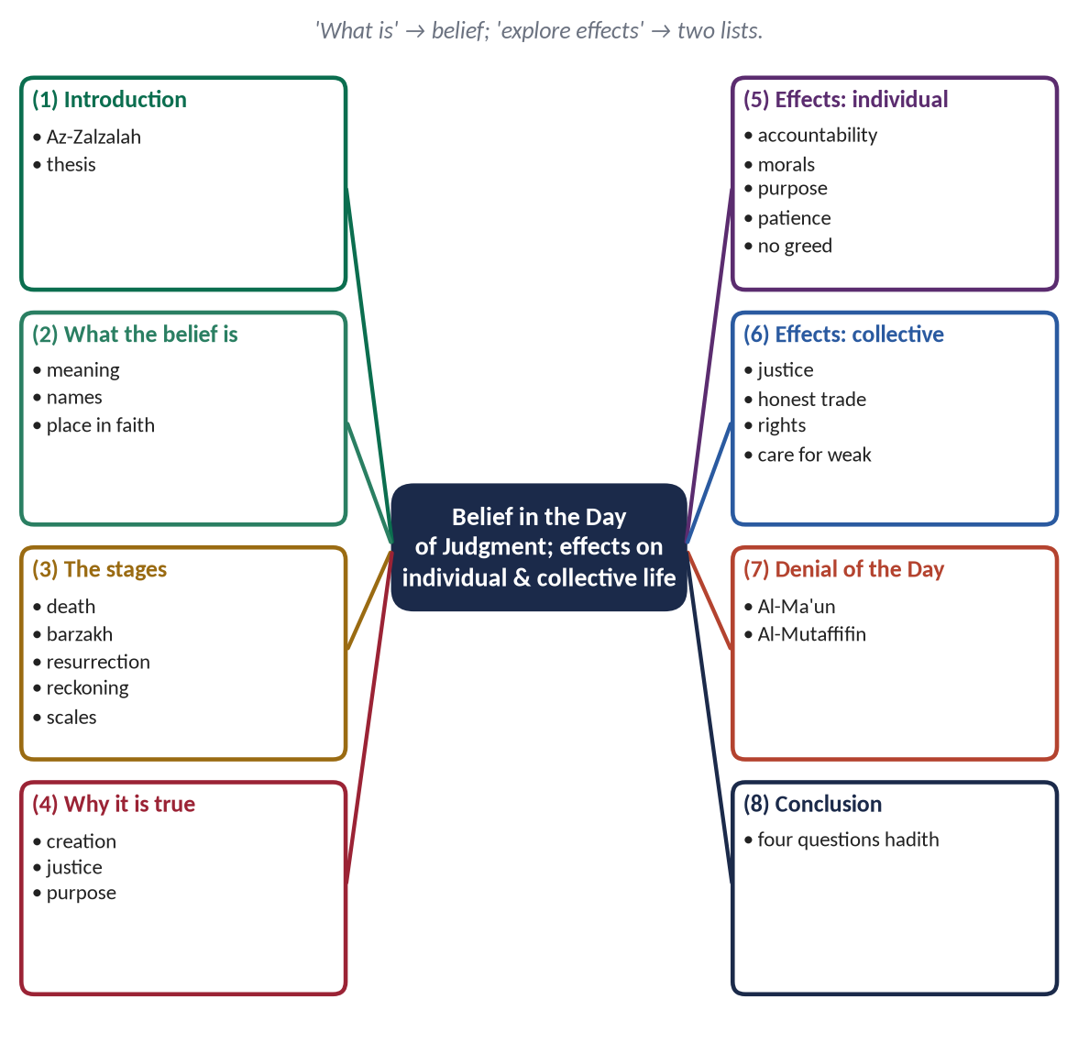
Figure 16 · The answer map: every branch is one numbered heading of the model answer below.

Decoding the question
- 'What is belief in the Day of Judgment?' — meaning, content (stages), and place in the faith; a short proof of its truth strengthens it.
- 'Explore its effects' — 'explore' invites depth: explain how the belief produces each effect.
- 'Individual and collective lives' — two headed sections of equal weight.

The model answer

(1) Introduction
✦ QURAN
﴿فَمَن يَعۡمَلۡ مِثۡقَالَ ذَرَّةٍ خَيۡرٗا يَرَهُۥ ۝ وَمَن يَعۡمَلۡ مِثۡقَالَ ذَرَّةٖ شَرّٗا يَرَهُۥ﴾
“So whoever does an atom's weight of good will see it. And whoever does an atom's weight of evil will see it.” (Az-Zalzalah, Quran)
➜ Whoever does an atom's weight of good will see it, and whoever does an atom's weight of evil will see it.

Of all the beliefs of Islam, belief in the Day of Judgment most directly shapes human behaviour. A person who believes that every word, deed and intention will be weighed on a Day of perfect justice cannot live carelessly. The Quran mentions this belief on almost every page and joins it with belief in Allah. This answer explains what the belief is, why it is true, and how it shapes the individual and the collective life of human beings.

(2) What belief in the Day of Judgment is

(i) Meaning
The belief that this world will end; all will be raised; every person will be judged for belief and deeds; and each will receive eternal reward or punishment by Allah's justice and mercy.

(ii) Its names
Yawm al-Qiyamah, Yawm al-Din, Yawm al-Hisab, Yawm al-Fasl — the Day of Rising, Recompense, Reckoning and Decision.

(iii) Its place in faith
✦ QURAN
﴿يَـٰٓأَيُّهَا ٱلَّذِينَ ءَامَنُوٓاْ ءَامِنُواْ بِٱللَّهِ وَرَسُولِهِۦ وَٱلۡكِتَٰبِ ٱلَّذِي نَزَّلَ عَلَىٰ رَسُولِهِۦ وَٱلۡكِتَٰبِ ٱلَّذِيٓ أَنزَلَ مِن قَبۡلُۚ وَمَن يَكۡفُرۡ بِٱللَّهِ وَمَلَـٰٓئِكَتِهِۦ وَكُتُبِهِۦ وَرُسُلِهِۦ وَٱلۡيَوۡمِ ٱلۡأٓخِرِ فَقَدۡ ضَلَّ ضَلَٰلَۢا بَعِيدًا﴾
“O you who have believed, believe in Allah and His Messenger and the Book that He sent down upon His Messenger and the Scripture which He sent down before. And whoever disbelieves in Allah, His angels, His books, His messengers, and the Last Day has certainly gone far astray.” (An-Nisa, Quran)
➜ Whoever disbelieves in Allah, His angels, His books, His messengers and the Last Day has gone far astray.

(3) The stages of the Hereafter
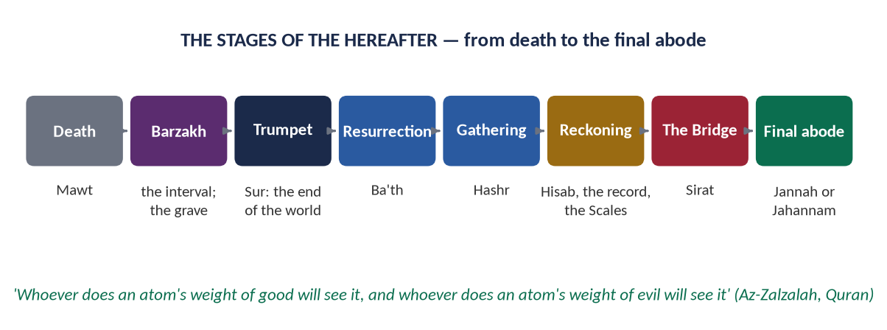
Figure 17 · The stages of the Hereafter.
- (a) Death: 'Every soul will taste death' (Aal-e-Imran).
- (b) Barzakh: the barrier-life until resurrection (Al-Mu'minun).
- (c) Resurrection and gathering: 'from their graves they hasten to their Lord' (Ya-Sin).
- (d) The record: 'Read your record; sufficient is yourself against you this Day' (Al-Isra).
- (e) The witnesses: hands and feet will testify (Ya-Sin).
- (f) The scales: 'We will set up the scales of justice' (Al-Anbiya).
- (g) Paradise and Hell: the final abode.

(4) Why the belief is true — in brief
- (a) The first creation: 'He will give them life who produced them the first time' (Ya-Sin).
- (b) Justice: the good and the evil cannot end alike (Al-Jathiyah).
- (c) Purpose: 'Did you think We created you uselessly?' (Al-Mu'minun).

(5) Effects on the individual life

(i) A sense of accountability
✦ HADITH
لَا تَزُولُ قَدَمَا عَبْدٍ يَوْمَ الْقِيَامَةِ حَتَّى يُسْأَلَ عَنْ عُمُرِهِ فِيمَا أَفْنَاهُ، وَعَنْ عِلْمِهِ فِيمَ فَعَلَ، وَعَنْ مَالِهِ مِنْ أَيْنَ اكْتَسَبَهُ وَفِيمَ أَنْفَقَهُ، وَعَنْ جِسْمِهِ فِيمَ أَبْلَاهُ
“A servant's feet will not move on the Day of Resurrection until he is asked about his life and how he spent it, his knowledge and what he did with it, his wealth — where he earned it and how he spent it — and his body and how he used it.” (Al-Tirmidhi)
➜ Four questions that govern time, knowledge, money and health.

(ii) Moral conduct and control of the tongue
✦ HADITH
مَنْ كَانَ يُؤْمِنُ بِاللَّهِ وَالْيَوْمِ الْآخِرِ فَلْيَقُلْ خَيْرًا أَوْ لِيَصْمُتْ
“Whoever believes in Allah and the Last Day should speak good or keep silent.” (Al-Bukhari and Muslim)
➜ The belief directly governs speech.

(iii) Purpose and seriousness
Life is a test with a result; time is not killed but invested.

(iv) Patience and hope in suffering
✦ QURAN
﴿وَلَنَبۡلُوَنَّكُم بِشَيۡءٖ مِّنَ ٱلۡخَوۡفِ وَٱلۡجُوعِ وَنَقۡصٖ مِّنَ ٱلۡأَمۡوَٰلِ وَٱلۡأَنفُسِ وَٱلثَّمَرَٰتِۗ وَبَشِّرِ ٱلصَّـٰبِرِينَ ۝ ٱلَّذِينَ إِذَآ أَصَٰبَتۡهُم مُّصِيبَةٞ قَالُوٓاْ إِنَّا لِلَّهِ وَإِنَّآ إِلَيۡهِ رَٰجِعُونَ ۝ أُوْلَـٰٓئِكَ عَلَيۡهِمۡ صَلَوَٰتٞ مِّن رَّبِّهِمۡ وَرَحۡمَةٞۖ وَأُوْلَـٰٓئِكَ هُمُ ٱلۡمُهۡتَدُونَ﴾
“And We will surely test you with something of fear and hunger and a loss of wealth and lives and fruits, but give good tidings to the patient. Who, when disaster strikes them, say, "Indeed we belong to Allah, and indeed to Him we will return. Those are the ones upon whom are blessings from their Lord and mercy. And it is those who are the [rightly] guided.” (Al-Baqarah, Quran)
➜ Good news to the patient, who say in calamity: 'To Allah we belong, and to Him we return.'

(v) Freedom from greed and materialism
✦ HADITH
كُنْ فِي الدُّنْيَا كَأَنَّكَ غَرِيبٌ أَوْ عَابِرُ سَبِيلٍ
“Be in this world as though you were a stranger or a traveller.” (Al-Bukhari)
➜ The traveller uses the world without being owned by it.

(vi) Self-accounting
✦ HADITH
الْكَيِّسُ مَنْ دَانَ نَفْسَهُ وَعَمِلَ لِمَا بَعْدَ الْمَوْتِ
“The wise person is the one who holds himself to account and works for what comes after death.” (Al-Tirmidhi)
➜ Muhasabah — daily self-audit — is the habit of a believer.

(6) Effects on the collective life

(i) Justice and responsible rulers
✦ SCHOLARLY VIEW
Hazrat Umar Farooq (RA) · the second Rightly-Guided Caliph
Hazrat Umar is reported to have said that if a dog died of hunger on the bank of the Euphrates, he feared Allah would ask Umar about it.
➜ Belief in the Day made a ruler answerable for every creature.

(ii) Honest trade
✦ QURAN
﴿وَيۡلٞ لِّلۡمُطَفِّفِينَ ۝ ٱلَّذِينَ إِذَا ٱكۡتَالُواْ عَلَى ٱلنَّاسِ يَسۡتَوۡفُونَ ۝ وَإِذَا كَالُوهُمۡ أَو وَّزَنُوهُمۡ يُخۡسِرُونَ ۝ أَلَا يَظُنُّ أُوْلَـٰٓئِكَ أَنَّهُم مَّبۡعُوثُونَ ۝ لِيَوۡمٍ عَظِيمٖ ۝ يَوۡمَ يَقُومُ ٱلنَّاسُ لِرَبِّ ٱلۡعَٰلَمِينَ﴾
“Woe to those who give less [than due]. Who, when they take a measure from people, take in full. But if they give by measure or by weight to them, they cause loss. Do they not think that they will be resurrected. For a tremendous Day. The Day when mankind will stand before the Lord of the worlds.” (Al-Mutaffifin, Quran)
➜ Woe to those who give less in measure … do they not think they will be resurrected for a tremendous Day?

(iii) The protection of people's rights
✦ HADITH
إِنَّ الْمُفْلِسَ مِنْ أُمَّتِي يَأْتِي يَوْمَ الْقِيَامَةِ بِصَلَاةٍ وَصِيَامٍ وَزَكَاةٍ، وَيَأْتِي قَدْ شَتَمَ هَذَا، وَقَذَفَ هَذَا، وَأَكَلَ مَالَ هَذَا، وَسَفَكَ دَمَ هَذَا، وَضَرَبَ هَذَا
“The bankrupt of my Ummah comes on the Day of Resurrection with prayer, fasting and Zakat, but he had abused this one, slandered that one, consumed this one's wealth, shed that one's blood and beaten this one.” (Muslim)
➜ On the Day, social wrongs are paid from one's good deeds — the strongest guarantee of human rights.

(iv) Care for the weak
✦ QURAN
﴿أَرَءَيۡتَ ٱلَّذِي يُكَذِّبُ بِٱلدِّينِ ۝ فَذَٰلِكَ ٱلَّذِي يَدُعُّ ٱلۡيَتِيمَ ۝ وَلَا يَحُضُّ عَلَىٰ طَعَامِ ٱلۡمِسۡكِينِ﴾
“Have you seen the one who denies the Recompense. For that is the one who drives away the orphan. And does not encourage the feeding of the poor.” (Al-Ma'un, Quran)
➜ The one who denies the Recompense drives away the orphan and does not encourage feeding the poor.

(v) Less crime and corruption; more trust
A society that believes every hidden act will be exposed needs less policing; trust becomes the currency of social life.

(vi) Peace instead of revenge
Because final justice is certain, the wronged can forgive or seek lawful justice without taking the law into their own hands.
PAKISTAN ANGLE · AN HONEST WORD
Nearly every Pakistani believes in the Day of Judgment, yet corruption, adulteration and tax evasion persist. The cause is not the belief but its reduction to ritual. The remedy: teaching the belief as accountability, not only as a story; muhasabah in schools and mosques; and strong accountability institutions that mirror the justice of the Day.

(7) The effects of denying the Day
The Quran itself shows the opposite: those who deny the Day cheat in trade (Al-Mutaffifin) and neglect the orphan and the poor (Al-Ma'un). Where belief in the Hereafter weakens, materialism, cruelty and injustice grow.

(8) Conclusion
Belief in the Day of Judgment turns a life of desire into a life of responsibility. For the individual it brings accountability, good speech, purpose, patience and freedom from greed; for society it brings just rulers, honest markets, protected rights and care for the weak. It is the belief that makes faith work — in the heart, in the home and in the state.
✦ QURAN
﴿وَنَضَعُ ٱلۡمَوَٰزِينَ ٱلۡقِسۡطَ لِيَوۡمِ ٱلۡقِيَٰمَةِ فَلَا تُظۡلَمُ نَفۡسٞ شَيۡـٔٗاۖ وَإِن كَانَ مِثۡقَالَ حَبَّةٖ مِّنۡ خَرۡدَلٍ أَتَيۡنَا بِهَاۗ وَكَفَىٰ بِنَا حَٰسِبِينَ﴾
“And We place the scales of justice for the Day of Resurrection, so no soul will be treated unjustly at all. And if there is [even] the weight of a mustard seed, We will bring it forth. And sufficient are We as accountant.” (Al-Anbiya, Quran)
➜ 'We will set up the scales of justice for the Day of Resurrection, so no soul will be wronged at all.'

Why this answer scores
- 'What is' is answered fully: meaning, names, place, stages (with a figure) and a short proof.
- 'Explore' is honoured: each effect explains how the belief produces it.
- The honest Pakistan angle shows maturity; the Muflis hadith links belief to human rights.

Answer 9 · The Quranic Argument on the Hereafter and Its Impacts (CSS 2023)
THE QUESTION · CSS 2023 · Q2 · 20 marks
What is the Qur'anic argument on the Life Hereafter? What are its impacts on the individual and collective life of a human being?

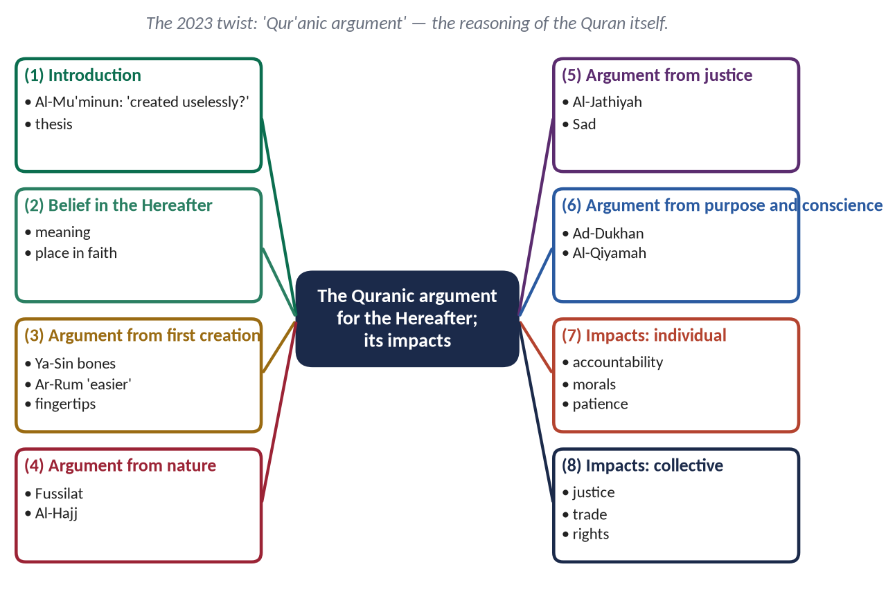
Figure 18 · The answer map: every branch is one numbered heading of the model answer below.

Decoding the question
- The 2021 family returns with a twist: not 'what is the belief' but 'what is the Qur'anic argument' — how the Quran proves the Hereafter. This must be the largest section.
- Present the Quran's arguments as arguments (reasoning), each with its verses.
- Then impacts on individual and collective life — in two sections.

The model answer

(1) Introduction
✦ QURAN
﴿أَفَحَسِبۡتُمۡ أَنَّمَا خَلَقۡنَٰكُمۡ عَبَثٗا وَأَنَّكُمۡ إِلَيۡنَا لَا تُرۡجَعُونَ﴾
“Then did you think that We created you uselessly and that to Us you would not be returned.” (Al-Mu'minun, Quran)
➜ 'Did you think that We created you uselessly, and that to Us you would not be returned?'

The Makkans did not deny God; they denied the Hereafter. 'When we are dust and bones, shall we really be raised?' they mocked. The Quran answered them not with threats alone but with arguments — from creation, from nature, from justice, from purpose and from the human conscience. This answer sets out the Quranic argument for the life Hereafter and then shows its impact on the individual and collective life of human beings.

(2) Belief in the Hereafter
The belief that all will be resurrected, judged for their deeds and rewarded or punished eternally. The Quran joins it with faith in Allah more than any other belief (Al-Baqarah: 'righteousness is to believe in Allah and the Last Day …').
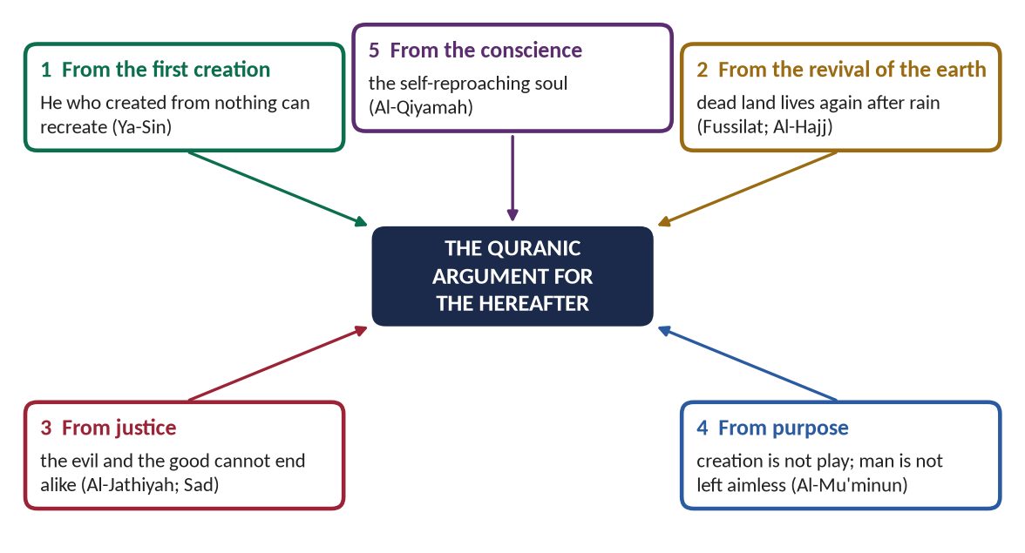
Figure 19 · The five Quranic arguments for the Hereafter.

(3) The argument from the first creation

(i) The reasoning
He who created from nothing can recreate; recreation is easier than creation.

(ii) The occasion and the verses
A Makkan crumbled a decayed bone before the Prophet ﷺ and asked who could revive it. The answer:
✦ QURAN
﴿وَضَرَبَ لَنَا مَثَلٗا وَنَسِيَ خَلۡقَهُۥۖ قَالَ مَن يُحۡيِ ٱلۡعِظَٰمَ وَهِيَ رَمِيمٞ ۝ قُلۡ يُحۡيِيهَا ٱلَّذِيٓ أَنشَأَهَآ أَوَّلَ مَرَّةٖۖ وَهُوَ بِكُلِّ خَلۡقٍ عَلِيمٌ﴾
“And he presents for Us an example and forgets his [own] creation. He says, "Who will give life to bones while they are disintegrated. Say, "He will give them life who produced them the first time; and He is, of all creation, Knowing.” (Ya-Sin, Quran)
➜ 'Who will give life to bones while they are decayed?' Say: 'He will give them life who produced them the first time; and He is, of all creation, Knowing.'

✦ QURAN
﴿وَهُوَ ٱلَّذِي يَبۡدَؤُاْ ٱلۡخَلۡقَ ثُمَّ يُعِيدُهُۥ وَهُوَ أَهۡوَنُ عَلَيۡهِۚ وَلَهُ ٱلۡمَثَلُ ٱلۡأَعۡلَىٰ فِي ٱلسَّمَٰوَٰتِ وَٱلۡأَرۡضِۚ وَهُوَ ٱلۡعَزِيزُ ٱلۡحَكِيمُ﴾
“And it is He who begins creation; then He repeats it, and that is [even] easier for Him. To Him belongs the highest attribute in the heavens and earth. And He is the Exalted in Might, the Wise.” (Ar-Rum, Quran)
➜ He begins creation and then repeats it, and that is easier for Him.

(iii) Even the fingertips
✦ QURAN
﴿أَيَحۡسَبُ ٱلۡإِنسَٰنُ أَلَّن نَّجۡمَعَ عِظَامَهُۥ ۝ بَلَىٰ قَٰدِرِينَ عَلَىٰٓ أَن نُّسَوِّيَ بَنَانَهُۥ﴾
“Does man think that We will not assemble his bones. Yes. [We are] Able [even] to proportion his fingertips.” (Al-Qiyamah, Quran)
➜ Does man think We will not assemble his bones? Yes — We are able to proportion even his fingertips.

(4) The argument from the revival of nature

(i) The reasoning
Every year the dead earth comes to life after rain; the same power will revive the dead.
✦ QURAN
﴿وَمِنۡ ءَايَٰتِهِۦٓ أَنَّكَ تَرَى ٱلۡأَرۡضَ خَٰشِعَةٗ فَإِذَآ أَنزَلۡنَا عَلَيۡهَا ٱلۡمَآءَ ٱهۡتَزَّتۡ وَرَبَتۡۚ إِنَّ ٱلَّذِيٓ أَحۡيَاهَا لَمُحۡيِ ٱلۡمَوۡتَىٰٓۚ إِنَّهُۥ عَلَىٰ كُلِّ شَيۡءٖ قَدِيرٌ﴾
“And of His signs is that you see the earth stilled, but when We send down upon it rain, it quivers and grows. Indeed, He who has given it life is the Giver of Life to the dead. Indeed, He is over all things competent.” (Fussilat, Quran)
➜ You see the earth barren; when We send down rain, it stirs and swells. He who gave it life will give life to the dead.

✦ QURAN
﴿… وَتَرَى ٱلۡأَرۡضَ هَامِدَةٗ فَإِذَآ أَنزَلۡنَا عَلَيۡهَا ٱلۡمَآءَ ٱهۡتَزَّتۡ وَرَبَتۡ وَأَنۢبَتَتۡ مِن كُلِّ زَوۡجِۭ بَهِيجٖ﴾
“And you see the earth barren; but when We send down rain upon it, it quivers and swells and brings forth every kind of beautiful growth.” (Al-Hajj, Quran)
➜ From dust, to a drop, to a clot … and the dead earth quivering with life — so will the resurrection be.

(5) The argument from justice

(i) The reasoning
In this world the oppressor often escapes and the oppressed often suffers without redress. A just Creator must bring a Day of Justice; otherwise the universe would be unjust.
✦ QURAN
﴿أَمۡ حَسِبَ ٱلَّذِينَ ٱجۡتَرَحُواْ ٱلسَّيِّـَٔاتِ أَن نَّجۡعَلَهُمۡ كَٱلَّذِينَ ءَامَنُواْ وَعَمِلُواْ ٱلصَّـٰلِحَٰتِ سَوَآءٗ مَّحۡيَاهُمۡ وَمَمَاتُهُمۡۚ سَآءَ مَا يَحۡكُمُونَ﴾
“Or do those who commit evils think We will make them like those who have believed and done righteous deeds - [make them] equal in their life and their death? Evil is that which they judge.” (Al-Jathiyah, Quran)
➜ Do those who commit evil think We will make them like those who believe and do good, equal in life and death? Evil is what they judge.

✦ QURAN
﴿أَمۡ نَجۡعَلُ ٱلَّذِينَ ءَامَنُواْ وَعَمِلُواْ ٱلصَّـٰلِحَٰتِ كَٱلۡمُفۡسِدِينَ فِي ٱلۡأَرۡضِ أَمۡ نَجۡعَلُ ٱلۡمُتَّقِينَ كَٱلۡفُجَّارِ﴾
“Or should we treat those who believe and do righteous deeds like corrupters in the land? Or should We treat those who fear Allah like the wicked.” (Sad, Quran)
➜ Should We treat the righteous like those who cause corruption?

(6) The argument from purpose and the conscience

(i) Purpose
✦ QURAN
﴿وَمَا خَلَقۡنَا ٱلسَّمَٰوَٰتِ وَٱلۡأَرۡضَ وَمَا بَيۡنَهُمَا لَٰعِبِينَ ۝ مَا خَلَقۡنَٰهُمَآ إِلَّا بِٱلۡحَقِّ وَلَٰكِنَّ أَكۡثَرَهُمۡ لَا يَعۡلَمُونَ﴾
“And We did not create the heavens and earth and that between them in play. We did not create them except in truth, but most of them do not know.” (Ad-Dukhan, Quran)
➜ We did not create the heavens and the earth in play; We created them only in truth.

(ii) The conscience
✦ QURAN
﴿لَآ أُقۡسِمُ بِيَوۡمِ ٱلۡقِيَٰمَةِ ۝ وَلَآ أُقۡسِمُ بِٱلنَّفۡسِ ٱللَّوَّامَةِ﴾
“I swear by the Day of Resurrection. And I swear by the reproaching soul [to the certainty of resurrection].” (Al-Qiyamah, Quran)
➜ 'I swear by the Day of Resurrection, and I swear by the self-reproaching soul' — the inner court of the conscience points to the outer Court of the Day.

(iii) A philosophical echo
The philosopher Immanuel Kant concluded that morality requires us to postulate the immortality of the soul, because virtue and happiness are not united in this life — an echo, centuries later, of the Quran's argument from justice.

(7) Impacts on individual life
- (a) Accountability: the four questions of the Day — life, knowledge, wealth, body (Al-Tirmidhi).
- (b) Good conduct: 'Whoever believes in Allah and the Last Day should speak good or keep silent' (Al-Bukhari and Muslim).
- (c) Purpose and seriousness: life as a test with a result (Al-Mulk).
- (d) Patience and hope: 'To Allah we belong and to Him we return' (Al-Baqarah).
- (e) Freedom from materialism: 'The Hereafter is better and more lasting' (Al-A'la).
✦ HADITH
أَكْثِرُوا ذِكْرَ هَاذِمِ اللَّذَّاتِ، يَعْنِي الْمَوْتَ
“Remember often the destroyer of pleasures — meaning death.” (Al-Tirmidhi)
➜ Remembering the end corrects priorities and cures arrogance.

(8) Impacts on collective life
- (a) Just and accountable rulers: Hazrat Umar's fear of being questioned for a starving dog on the Euphrates.
- (b) Honest markets: 'Woe to the defrauders … do they not think they will be resurrected?' (Al-Mutaffifin).
- (c) Human rights guaranteed: the Muflis whose good deeds are paid to those he wronged (Muslim).
- (d) Care for the weak: the denier of the Recompense drives away the orphan (Al-Ma'un).
- (e) Social trust and peace: less crime, less revenge, more cooperation.
✦ QURAN
﴿لَّيۡسَ ٱلۡبِرَّ أَن تُوَلُّواْ وُجُوهَكُمۡ قِبَلَ ٱلۡمَشۡرِقِ وَٱلۡمَغۡرِبِ وَلَٰكِنَّ ٱلۡبِرَّ مَنۡ ءَامَنَ بِٱللَّهِ وَٱلۡيَوۡمِ ٱلۡأٓخِرِ وَٱلۡمَلَـٰٓئِكَةِ وَٱلۡكِتَٰبِ وَٱلنَّبِيِّـۧنَ وَءَاتَى ٱلۡمَالَ عَلَىٰ حُبِّهِۦ ذَوِي ٱلۡقُرۡبَىٰ وَٱلۡيَتَٰمَىٰ وَٱلۡمَسَٰكِينَ وَٱبۡنَ ٱلسَّبِيلِ …﴾
“Righteousness is not that you turn your faces toward the east or the west; but true righteousness is [in] one who believes in Allah, the Last Day, the angels, the Book and the Prophets, and gives wealth, in spite of love for it, to relatives, orphans, the needy and the traveller …” (Al-Baqarah, Quran)
➜ Righteousness is believing in Allah and the Last Day … and giving wealth to relatives, orphans, the needy, the traveller and those who ask, and freeing slaves — belief in the Hereafter produces social welfare.

PAKISTAN ANGLE
A nation where belief in the Hereafter is nearly universal yet public trust is low needs to turn belief into accountability: character education, honest institutions and leaders who remember that they will be questioned.

(9) Conclusion
The Quran argues for the Hereafter as a teacher argues with a student: look at your own creation, look at the earth after rain, look at the injustice around you, look at the purpose in the universe and the conscience in your soul — and you will see that a Day of Return is not only possible but necessary. Believed in this way, the Hereafter produces accountable individuals and a just society.
✦ QURAN
﴿كُلُّ نَفۡسٖ ذَآئِقَةُ ٱلۡمَوۡتِۗ وَإِنَّمَا تُوَفَّوۡنَ أُجُورَكُمۡ يَوۡمَ ٱلۡقِيَٰمَةِۖ فَمَن زُحۡزِحَ عَنِ ٱلنَّارِ وَأُدۡخِلَ ٱلۡجَنَّةَ فَقَدۡ فَازَۗ وَمَا ٱلۡحَيَوٰةُ ٱلدُّنۡيَآ إِلَّا مَتَٰعُ ٱلۡغُرُورِ﴾
“Every soul will taste death, and you will only be given your [full] compensation on the Day of Resurrection. So he who is drawn away from the Fire and admitted to Paradise has attained [his desire]. And what is the life of this world except the enjoyment of delusion.” (Aal-e-Imran, Quran)
➜ Every soul will taste death, and you will be paid your full reward only on the Day of Resurrection. Whoever is drawn away from the Fire and admitted to Paradise has succeeded; and the life of this world is only the enjoyment of delusion.

Why this answer scores
- It answers the 2023 twist: the Quranic argument is the core, set out as five arguments with their reasoning and verses.
- It adds a philosophical echo (Kant) without replacing the Quran.
- Impacts are concise but complete, because the question's weight lies on the argument.

